Fall 2020
Year Seven
Self-Evaluation Report

Prepared for the Northwest Commission on Colleges and Universities

This page left intentionally blank

Submitted August 2020
Year Seven Self-Evaluation Report
Prepared for the Northwest Commission on Colleges and Universities

Dr. Bradley J. Cook
President

Dr. Steven J. Hood
Vice President, Academic Affairs
College Provost

Dr. Beckie Hermansen
Executive Director, Institutional Research and Effectiveness
Accreditation Liaison Officer

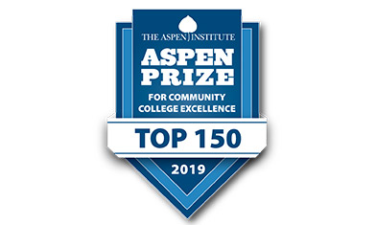

This page left intentionally blank

Table of Contents
Institutional Overview 1
Basic Institutional Data Form 1
Preface 9
Update on Institutional Changes 10
Response to Recommendations Previously Requested by the Commission 11
Standard 1: Mission, Core Themes and Expectations 17
Executive Summary of Eligibility Requirements 2 and 3 18
Eligibility Requirement 2: Authority 18
Eligibility Requirement 3: Mission and Core Themes 18
Standard 1.A Mission and Core Themes 19
Standard 1.B Mission and Core Themes 22
Standard 2: Resources and Capacity 1
Executive Summary of Eligibility Requirements 4-21 2
Standard 2A - Governance 10

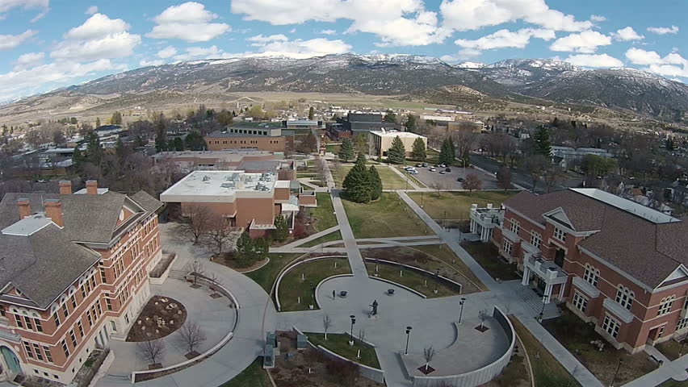
Institutional Overview

2020 Year Seven Self-Evaluation Report

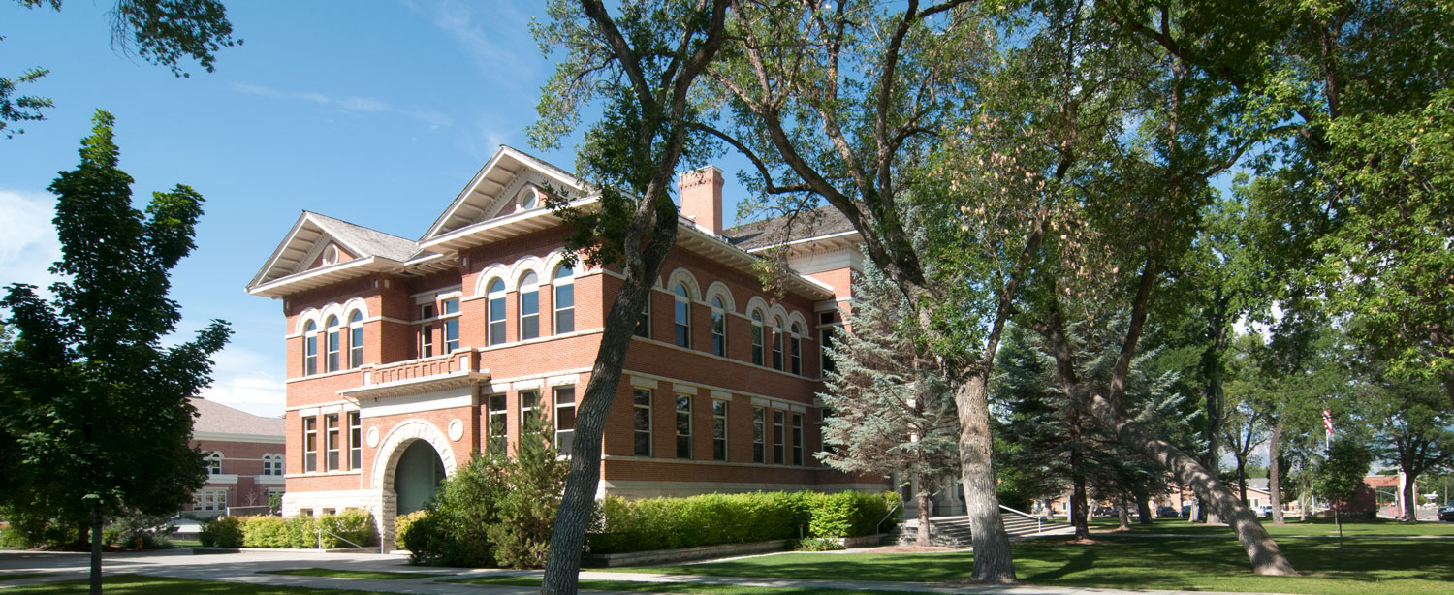

Institutional Overview

Snow College is one of eight public colleges and universities in the Utah System of Higher Education (USHE) governed by a nineteen-member Utah State Board of Regents appointed by the Governor. Snow College also has a ten-member board of trustees, who are appointed by the Governor.
Founded in 1888, Snow College is one of the oldest two-year state colleges in the western United States. Originally established as a residential academy, the institution provided teaching and learning opportunities tailored to the formative years of early adult and adult learning. Today, Snow College is a comprehensive two-year community college with campuses in Ephraim and Richfield. Its purpose is to transmit knowledge and skills through transfer education, a bachelor of commercial arts (in music) degree, associate of arts and associate of science degrees along with offering associate of applied science degrees, career and technical education, customized training for employers, developmental education, and strong student services to support these functions. Emphasis is placed on teaching, training, scholarly, professional, and creative achievement, and community service (taken from the 2014-2015 Snow College Catalog).
Most course offerings are delivered live in a face-to-face format, frequently with technology enhancement, with some courses broadcast from one campus to another. Some limited Snow College courses are offered at the Central Utah Correctional Facility in Gunnison and in area high schools. Students also have access to Snow College programs through online distance education offerings. Snow College is a teaching institution which means the majority of faculty (66%) devote their full attention to instructing students.
The composition of the student body is approximately 40 percent from the local six-county area, another 40 percent from elsewhere in Utah, and 20 percent from other states and international locations. Since 2008, Snow College has been the clear leader in enrollment growth among all state higher education institutions with 45% headcount and 26% FTE growth, respectively.
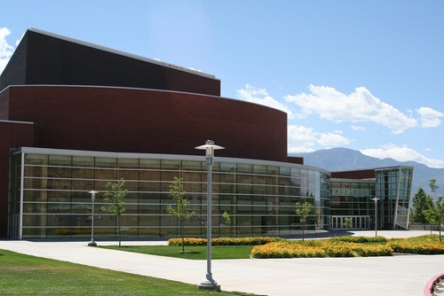
Snow's rural location is a wonderful setting for a college. Students and their parents like the fact that Snow is a safe, comfortable environment. There is a real feeling of 'family' at Snow with many students representing the third or fourth generation of their family at the college.
The College also serves as the intellectual, artistic, musical, educational, and sports center of central Utah. The institution is accredited by the Northwest Commission for Colleges and Universities and holds specialized program accreditation by the National Association for Schools of Music, the National Association for Schools of Theatre, the Association of Collegiate Business Schools and Programs, and Accreditation for Education in Nursing.
In recognition of the quality of Snow College, the Aspen Institute, headquartered in Washington, D.C., recently announced that Snow College was included in their list of “120 Top U.S. Community Colleges” for the fifth year in a row (http://www.aspeninstitute.org/policy-work/college-excellence/overview). Additionally, our collegiate performance groups have been honored across the intermountain west and the athletic programs are consistently ranked among the best in the country. Notably, the women’s basketball team has achieved the highest academic team recognition from the National Junior Collegiate Association for two years running (2014 and 2015).
Student Demographics

Faculty Demographics

Key Partnerships

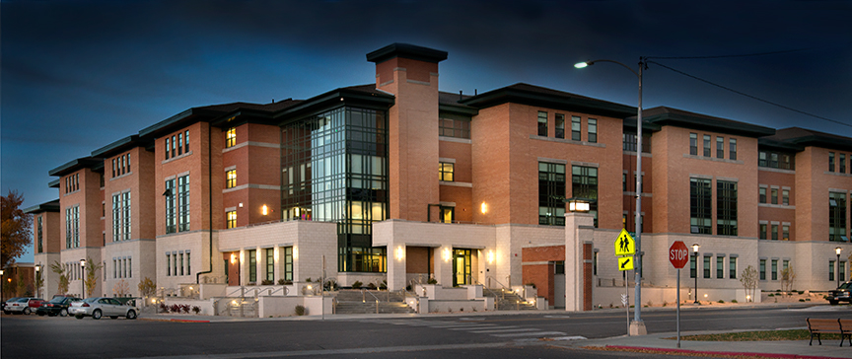

Basic Institutional Data Form
Information and data provided in the institutional annual report data form are from the academic and fiscal year preceding the year of the evaluation committee visit. The purpose of this form is to provide Commissioners and evaluators with current data for the year of the visit. After the self-evaluation report has been finalized, complete this form to ensure the information is current for the time of the evaluation committee visit. Please provide a completed copy of this form with each copy of the self-evaluation report sent to the Commission office and to each evaluator. To enable consistency of reporting, please refer to the glossary in the 2003 Accreditation Handbook for definitions of terms.
Institution: Snow College
Address: 150 E College Avenue
City, State, Zip: Ephraim, Utah 84627
Degree Levels Offered: ☐ Doctorate ☐ Masters ☐ Baccalaureate ☐ Associate ☐ Other
If part of a multi-institutional system, name the system: Utah System of Higher Education
Type of Institution: ☐ Comprehensive ☐ Specialized ☐ Health-centered ☐ Religious-based
☐ Native/Tribal ☐ Other (specify) ___________________________________________________
Institutional Control: ☐ Public ☐ City ☐ County ☐ State ☐ Federal ☐ Tribal
☐ Private/Independent (☐ Non-Profit ☐ for Profit)
Institutional Calendar: ☐ Quarter ☐ Semester ☐ Trimester ☐ 4-1-4 ☐ Continuous Term
☐ Other (specify) ____________________________________________________________________

Specialized/Programmatic Accreditation: List program or school, degree level(s) and date of last accreditation by an agency recognized by the United States Department of Education.
College/Division | Department | Accrediting Agency | Accreditation Period
Business & Applied Technologies | Automotive Technology | National Automotive Technicians Education Foundation
Business & Applied Technologies | Business | Association of Collegiate Business Schools and Programs
Business & Applied Technologies | Nursing | Accreditation for Education in Nursing
Fine Arts & Communications | Music | National Association of Schools of Music
Fine Arts & Communications | Theatre | National Association of Schools of Theatre

Full-Time Equivalent (FTE) Enrollment: The formula used to compute FTE = total undergraduate credit hours/15 + total graduate credit hours/10).
Official Fall 2020 (most recent year) FTE Student Enrollments
Classification | Current Year  (Fall 2020) | One Year Prior  (Fall 2019) | Two Years Prior  (Fall 2018)
Undergraduate
Graduate
Professional
Unclassified
Total all levels:

Full-time Unduplicated Headcount (count students enrolled in credit courses only).
Official Fall 2020 (most recent year) Student Headcount Enrollments
Classification | Current Year  (Fall 2020) | One Year Prior  (Fall 2019) | Two Years Prior  (Fall 2018)
Undergraduate
Graduate
Professional
Unclassified
Total all levels:

Other Student Demographics
Graduation, Transfer and Retention Rates
Classification | Cohort Year (YYYY)  most recent available year | Graduation Rate (150% of normal time) | Graduation Rate (200% of normal time)
Graduation Rates
 | Cohort Year (YYYY)  most recent available year | Full-Time, First-Time Transfer Rate
Transfer Out rate
 | Cohort Year (YYYY)  most recent available year | Full-time | Part-time
Retention Rate

Numbers of Full-Time and Part-Time Instructional Research Faculty and Staff and Numbers of Full-Time (only) Instructional and Research Faculty and Staff by Highest Degree Earned. Include only professional personnel who are primarily assigned to instruction or research.
Total Number |  |  | Number of Full-Time (only) Faculty and Staff by Highest Degree Earned
Rank | Full-Time | Part-Time | Less than Associate | Associate | Bachelor | Masters | Specialist | Doctorate
Professor
Associate Professor
Assistant Professor
Instructor
Lecturer and Teaching Assistant
Research Staff and Research Assistant
Undesignated Rank

Mean Salaries and Mean Years of Service of Full-Time Instructional and Research Faculty and Staff. Include only full-time personnel with professional status who are primarily assigned to instruction or research.
Rank | Mean Salary | Mean Years of Service
Professor
Associate Professor
Assistant Professor
Instructor
Lecturer and Teaching Assistant
Research Staff and Research Assistant

Financial Information. Complete each item in the report using zero where there is nothing to report. Enter figures to the nearest dollar. Auxiliary and service enterprises of the institution (housing, food service, book stores, athletics, etc.) should be included. The institution’s audit materials should be an excellent reference for completing the report.
Fiscal Year of the Institution | 7/1/2019 – 6/30/2020 | 7/1/2018 – 6/30/2019 | 7/1/2017 – 6/30/2018
Reporting of income: | Accrual Basis | Accrual Basis | Accrual Basis
Reporting of expenses: | Accrual Basis | Accrual Basis | Accrual Basis

BALANCE SHEET DATA
ASSETS | Last Completed FY  (FY 2020) | One Year Prior to Last Completed FY  (FY 2019) | Two Years Prior to Last Completed FY  (FY 2018)
CURRENT FUNDS
Unrestricted
Cash
Investments
Accounts receivable gross
Less allowance for bad debts
Inventories
Prepaid expenses and deferred charges
Others (identify)
Due from
Total Unrestricted
Restricted
Cash
Investments
Other (identify)
Due from
Total Restricted
TOTAL CURRENT FUNDS
ENDOWMENT AND SIMILAR FUNDS
Cash
Investments
Other(identify)
Due from
TOTAL ENDOWMENT AND SIMILAR FUNDS
PLANT FUND
Unexpended
Cash
Investments
Other(Accounts Receivable)
Total unexpended
Investment in Plant
Land
Land improvements
Buildings
Equipment
Library resources
Other (CIP)
Total investment in plant
Due from
Other plant funds (identify)
TOTAL PLANT FUNDS
OTHER ASSETS (IDENTIFY)
TOTAL OTHER ASSETS
TOTAL ASSETS

BALANCE SHEET DATA (continued)
LIABILITIES | Last Completed FY  (FY 2020) | One Year Prior to Last Completed FY  (FY 2019) | Two Years Prior to Last Completed FY  (FY 2018)
CURRENT FUNDS
Unrestricted
Accounts payable
Accrued liabilities
Students’ deposits
Deferred credits
Other: Compensated Absences and Termination Benefits and Other
Due to State Agencies
Fund Balance
Total Unrestricted
Restricted
Accounts payable
Other (Annuities Payable
Due to
Fund Balance
Total Restricted
TOTAL CURRENT FUNDS
ENDOWMENT AND SIMILAR FUNDS
Restricted
Quasi-endowed
Due to
Fund balance
TOTAL ENDOWMENT AND SIMILAR FUNDS
PLANT FUND
Unexpended
Accounts payable
Notes payable
Bonds payable
Other liabilities (identify)
Due to
Fund balance
Total unexpended
Investment in Plant
Notes payable
Bonds payable
Mortgage payable
Other liabilities (identify)
Due to
Other plant fund liabilities (identify)
TOTAL INVESTMENT IN PLANT FUND
OTHER LIABILITIES (IDENTIFY)
TOTAL OTHER LIABILITIES
TOTAL LIABILITIES
FUND BALANCE

CURRENT FUNDS, REVENUES, EXPENDITURES, AND OTHER CHANGES
REVENUES | Last Completed FY  (FY 2020) | One Year Prior to Last Completed FY  (FY 2019) | Two Years Prior to Last Completed FY  (FY 2018)
Tuition and fees
Federal appropriations
State appropriations
Local appropriations
Grants and contracts
Endowment income
Auxiliary enterprises
Other (private gifts, grants, contracts)
Other (sales and service of Educ. Activities)
Other sources
Total Current Fund Revenues
EXPENDITURE AND MANDATORY TRANSFERS
Educational and General
Instruction
Research
Public Services
Academic Support
Student Services
Institutional Support
Operation and Maintenance of Plant
Scholarships and Fellowships
Other (identify)
Mandatory transfers for:
Principal and interest
Renewal and Replacements
Loan Fund and Matching Grants
Other (identify)
Total Educational and General
Auxiliary Enterprises
Expenditures
Mandatory transfers for:
Principal and Interest
Renewals and Replacements
Total Auxiliary Enterprises
TOTAL EXPENDITURE AND MANDATORY TRANSFERS
OTHER TRANSFERS AND ADDITIONAL/DELETIONS (identify)
EXCESS [deficiency of revenues over expenditures and mandatory transfers (net change in fund balances)]

INSTITUTIONAL INDEBTEDNESS
TOTAL DEBT TO OUTSIDE PARTIES | Last Completed FY  (FY 2020) | One Year Prior to Last Completed FY  (FY 2019) | Two Years Prior to Last Completed FY  (FY 2018)
For Capital Outlay
For Operation

Substantive Changes/Program Name Changes: Substantive changes including degree or certificate programs planned for and approved by the institution’s governing body (add additional pages if necessary). This also includes program name changes or changes where 25% of the student learning outcomes have changed.
SUBSTANTIVE CHANGES OR PROGRAM NAME CHANGES
(where 25% of the learning outcomes have changed)
Substantive Change | Certificate/Degree Level | Program Name | Discipline or Program Area

Domestic Off-Campus Degree Programs and Academic Credit Sites: Report information for off-campus sites within the United States where degree and academic coursework is offered (add additional pages if necessary).
- Degree Programs: list the names of degree programs that can be completed at the site.
- Academic Credit Courses: report the total number of academic credit courses offered at the site.
- Student Headcount: report the total number (unduplicated headcount) of students currently enrolled in programs at the site.
- Faculty Headcount: report the total number (unduplicated headcount) of faculty (full-time and part-time) teaching at the site.
PROGRAMS AND ACADEMIC CREDIT OFFERED AT OFF-CAMPUS SITES WITHIN THE UNITED STATES
Location of Site  Name  City, State, ZIP | Degree Program | Academic Credit Courses | Student Headcount | Faculty Headcount

Distance Education Sites: Degree and Certificate Programs of 30 semester or 45 quarter credits or more where at least 50% or more of the curriculum is offered by Distance Education, including ITV, online, and competency-based education. Adjust entries to category listings below as appropriate (add additional pages if necessary).
DISTANCE EDUCATION SITES
Name of Site | Physical Address | Degree/Certificate Name/Level | Program Name | Student Enrollment (unduplicated headcount) | On-Site Staff (Y/N) | Co-Sponsoring Organization

Programs and Academic Courses Offered at Sites Outside the United States. Report information for sites outside the United States where degree programs and academic credit courses are offered, including study abroad programs and education operations on military bases (add additional pages if necessary).
- Degree Programs: list the names of degree programs that can be completed at the site.
- Academic Credit Courses: report the total number of academic credit courses offered at the site.
- Student Headcount: report the total number (unduplicated headcount) of students currently enrolled in programs at the site.
- Faculty Headcount: report the total number (unduplicated headcount) of faculty (full-time and part-time) teaching at the site.
PROGRAMS AND ACADEMIC CREDIT OFFERED AT OFF-CAMPUS SITES OUTSIDE THE UNITED STATES
Location of Site  Name  City, State, ZIP | Degree Program | Academic Credit Courses | Student Headcount | Faculty Headcount

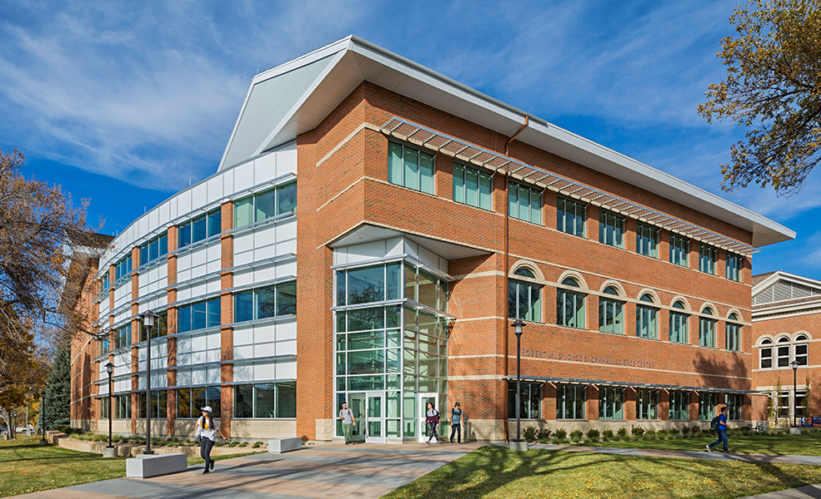

Preface

2020 Year Seven Self-Evaluation Report

Update on Institutional Changes
The Year Seven Self-Study provided Snow College the opportunity to reflect on progress made as well as anticipate future improvement. Significant institutional changes since the 2015 Mid-Cycle Report include the following:
- Construction of new science building: Approved by the Utah State Legislature on March 12, 2015 with support from a capital Science Building Campaign, this new and modern building serves as an anchor for the College’s STEM programs. The facility features at least four modern lecture rooms, ten high-tech integrated classrooms/labs, six additional advanced labs, and new spaces where faculty and students can collaborate and explore. Its physical construction represents science themes and interactive displays immersing all who enter the structure into a world of science.
- Associate Vice President of Academic Affairs/General Education Director: With the implementation of a Certificate in General Education, Snow College established a full-time General Education Director position, fall 2015. Progression toward a new, integrative General Education model along with the need for improved administrative governance of faculty policy, compensation, and instructional development transformed the GE Director position into the Associate Vice President of Academic Affairs position. The GE Director was appointed to this position, fall 2017.
- Bachelor of Science in Software Engineering degree: The Utah State Board of Regents approved Snow College’s request to offer a Bachelor of Science (BS) in Software Engineering effective Fall Semester, 2017. The degree will include three areas of emphasis which students may choose: Entrepreneurship, Digital Media Design, and Web Development. The Bachelor of Science in Software Engineering degree prepares software engineers: collaborative professionals working on a team to develop software products on time, within budget, and that meet customer requirements. Graduates of this program will possess the practical knowledge and skill of a defined engineering approach for complex systems analysis, planning, design and construction.
- Bachelor of Science in Business Partnership with Utah State University: Beginning fall 2018, a partnership between Utah State University’s (USU) Jon M. Huntsman School of Business and Snow College’s Business Department provided a way for Snow College students to remain in Ephraim, while earning a USU bachelor’s degree in either business administration or marketing. Students who complete their two-year Associate of Science Business degree at Snow seamlessly move into their third and fourth years of USU’s bachelor’s degree. In addition to the two bachelor’s degrees in business administration and marketing, the Huntsman School will also deliver minors in entrepreneurship and technical sales. Both minors could be valuable additions to the business-related majors and also to the two bachelor programs at Snow College in commercial music and software engineering.
- Significant Legislative Funding: The 2018 Utah State Legislative Session awarded Snow College nearly $8.2 million dollars in on-going and one-time funds. The most significant portion of funding ($1,135,000) was earmarked for compensation equity adjustments, allowing the College to address salary equity challenges compared to community colleges with similar missions. This was in addition to a 2.5% state-wide salary increase. The additional dollars were allocated to support economic development, dual/concurrent enrollment offerings, high-impact positions, an integrative model for general education, and expansions to the college’s nursing and software engineering program.
- Implementation of a Strategic Enrollment Management Plan: Starting fall 2017, Snow College commenced the development of a comprehensive strategic enrollment management plan in response to stagnant first-year student enrollments and in support of goals associated with the College’s strategic plan. The plan enables Snow College to navigate the shifting tides of student recruitment and stem the wayward drift of students leaving before degree completion. The plan emphasized the need for Snow College to adapt to the times and focus on strategies that will shore-up the College’s financial footings, allow the College to provide a top-notch education for our students, and maintain Snow College’s status as one of America’s premier two-year high education institutions.
- Presidential Retirement and Administrative Appointments:
  - President Gary L. Carlston announced his retirement in May 2018. The Utah State Board of Regents appointed a search committee and conducted a nation-wide search for the 17th president of the college.
  - Vice President of Student Services Craig Mathie retired from Snow College in January 2019.

Response to Recommendations Previously Requested by the Commission
This Year Seven Self-Study responds to the recommendations made by NWCCU following the Year One Self Study and review.
Recommendations following the Year One Self-Study and Review
- Snow College must continue to develop and update financial policies that are approved by its governing board regarding oversight and management of financial resources. It is recommended that the College clearly define and consistently follow its approved policies, guidelines, and processes for financial planning and budget development that include appropriate opportunities for participation by its constituencies (Standard 2.A.30 and 2.F.3).
The College Budget and Finance Office strives to keep its policies and procedures updated to maintain compliance with the ever changing rules and regulations issued by Federal, State, and other relevant agencies, as well as protect the overall financial health of the College. Official College finance policies are drafted under the direction of the Vice President of Finance and Administrative Services and follows the institution’s established policy approval procedure https://www.snow.edu/general/policies/101%20Policy%20Development%20and%20Review%20Policy.pdf). The College’s Payment Card Handling Policy was officially approved in January 2013 and is found on the College’s website under the Budget and Finance Office webpage (https://www.snow.edu/general/policies/201%20Cash%20Policy.pdf).
Updated tuition collection procedures changed the tuition payment deadline from the 21st day to the 5th day of each semester. The updated procedures were put into effect for the fall 2015 semester and have already resulted in significant improvements in the tuition collection payments compared to prior years. As a result of the strategic plan, the Budget and Finance Office was restructured, adding two new position.
- The College must continue to clarify, update, and organize academic policies—including those related to teaching, service, scholarship, research, and artistic creation—and clearly communicate them to students and faculty and to administrators and staff along with responsibilities related to these areas (Standard 2.A.12).
Since the May 2016 Ad Hoc Report, Snow College conducted a systematic and comprehensive review of all current Snow College polices as well the institution’s process for policy development and review. This review resulted in the following improvements:
- Enhanced practices for policy development and policy review;
- Improved policy organization under distinct Vice Presidents holding main responsibility for policy implementation;
- Greater transparency of policy development, review, and approval using a variety of communication channels;
This review directly influenced academic policies related to faculty hiring, faculty review, and faculty governance. Specific improvements were made to faculty leadership, academic workload, academic advancement for tenure-track and professional track positions, and faculty governance as represented by newly revised Faculty Senate By-Laws and Curriculum Committee By-Laws. These policies were organized under the Vice President of Academic Affairs (sections 400-412 of the Snow College Policy Handbook—see https://www.snow.edu/general/policies/index.html).
The following represent academic policies that have been approved since the 2012 Peer Review Report that resulted in Recommendation 2. These policies are organized under the Vice President of Academic Affairs (sections 400 – 412) and can be reviewed in detail on-line at https://www.snow.edu/general/policies/index.html.
- Snow College Credit Hour Policy (approved March 2013): This policy defines the credit hour for Snow College as applied to instruction, laboratory work, internships, practica, and studio work.
See https://www.snow.edu/catalog/academic_policies.html#credit
- Professional Track and Non-Tenure Track Faculty Promotion (updated and approved May 2014): Updates were made to this existing policy regarding the eligibility and process for professional track/non-tenure track promotion.
See https://www.snow.edu/general/policies/411-professional_track.html

The following represent academic procedures and/or policies that have been approved since the 2016 Ad Hoc Report on Recommendation 2. These policies are organized under the Vice President of Academic Affairs (sections 400 – 412) and can be reviewed in detail on-line at https://www.snow.edu/general/policies/index.html.

- Academic Workload Policy (approved August 2017): This policy defined the role of faculty according to state-mandated acceptable teaching loads. It also further clarified lab, studio, and other non-traditional teaching requirements; addressed multiple course sections and large class sizes taught using distance education technology; and outlined appropriate release time for deans, department chairs and general faculty with administrative or other special assignments.
See https://www.snow.edu/general/policies/404-academic_workload.html
- Advancement and Tenure Policy (pending approval fall 2018): The Advancement and Tenure policy was re-written to emphasize the following main areas: standards of good teaching, service to the College, and professional development. The new document eliminated a confusing point-system, clarified the review process, established a better timeline for review, and established an appeals process. This document was written by an ad hoc faculty committee, the Vice President of Academic Affairs, and state-appointed legal counsel. The document was presented to the campus community for a 60-day review (spring 2018). A final draft will be presented to College Council in August pursuant to policy #101.

- Responsibilities of Dean and Department Chairs Document (Spring 2015): This document clarified the roles of division deans and program/department chairs in terms of academic leadership, workload release, adjunct hiring, faculty review, program review, and fiduciary responsibility. This document was written by the Vice President of Academic Affairs, the Associate Vice President of Academic Affairs, and respective division deans. Not considered policy, this document was sent out to all faculty for 30-day review and was the topic of many in-person faculty meetings at the division and department level prior to being ratified as an official procedural document. Subsequently, the Vice President and Associate Vice President of Academic Affairs established monthly dean and department chair training meetings. These meetings provide deans and department chairs an additional avenue for policy and/or procedural discussion as well as academic leadership training. The results have been the establishment of a faculty mentoring system (particularly between new and existing faculty) and the cross-pollination of ideas and best practices among departments. The transparent delineation of dean and department chair duties greatly facilitated progress toward a new workload policy and supported revision efforts governing faculty tenure and advancement.
- Rules for the Appointment and Review of Deans and Department Chairs (fall 2016): Not considered policy, this document outlined a new process for the selection of deans and department chairs that moved away from an inconsistent and highly debated election process to an official application procedure open to all tenure-track faculty. This document also outlined the practice of regular dean and department chair performance reviews by the Vice President of Academic Affairs and program-distinct full and part-time faculty. This document was written by the academic division deans and the Vice President of Academic Affairs and was accepted as an official procedural document by the faculty after the 30 day comment period.
- Curriculum Committee Bylaw and General Education Committee Bylaw Revisions (spring 2016): Not considered official policy, Snow College’s Curriculum Committee and General Education Committee completed revisions to their bylaws spring semester 2016. These revisions followed the same procedure for policy proposal by completing a 30-day college community review. Revisions made to the bylaws more accurately reflected the regular operations of the respective committees and provide for better alignment between the institution’s general education curriculum and the work of the General Education Committee (a sub-committee of the Curriculum Committee).

- Faculty Senate By-Laws (pending approval fall 2018): Snow College’s Faculty Senate oversees the work of the Advancement and Tenure Committee as well as the Curriculum Committee. As a result, revisions to the Advancement and Tenure guidelines and Curriculum Committee rules support improvements to Snow College’s Faculty Senate bylaws.
- While recognizing the College’s purposeful, systematic, integrated, and comprehensive planning, it is recommended this be an ongoing process leading to mission fulfillment. Implemented plans must be made available to appropriate constituencies. In addition, it is recommended that the institution’s planning process continue to be broad-based and offer opportunities for input by appropriate constituencies.
Snow College acknowledged the practice of a few past administrators to make single-handed decisions. Such decisions were communicated to Snow College personnel void of the consultation that should have occurred during the decision-making process. With feedback from faculty and staff regarding these inefficiencies, the College commenced to correct these behaviors by engaging in a systematic and comprehensive strategic planning process leading to mission fulfillment.
Central to the strategic planning process was the meaningful engagement with internal and external stakeholders in a manner that was collaborative and transparent. Strategic task forces members, attended department, division, area, and small group meetings to answer questions and gather extra feedback. Concept papers were circulated among all personnel and two large-group “conferences” mixed solicited feedback from college personnel and external stakeholders. All meeting minutes, concept papers, and other written work (including news, events, and resources) were published to a public strategic planning web-site. This entire process spanned nine months and involved every campus community member as well as key external associates.
Since then, additional proposals (such as distinct four-year degree program proposals) have assimilated the same process. For example, the General Education Committee continued to meet with the various academic and non-academic units of the College to gather input on a newly proposed general education model. And efforts toward the revision of a faculty workload policy have involved faculty and staff on both campuses communicating openly through structured meetings and one-on-one conversations. That policy was approved by the Snow College Board of Trustees in August 2017. Additionally, the college president holds a comprehensive assembly prior to each fall semester and regular (at least 4 to 5 times a year) “town-hall” type meetings (Conversations with the President) with faculty and staff on both the Ephraim and Richfield campuses regarding institutional progress and legislative developments.
The practice of seeking broad-based input from various College constituencies has proved to be time-consuming and imperfect. However, these efforts have advanced campus morale and attest to be worthwhile activities. The College will continue to provide avenues for across-the-board collaboration and transparent communication in the advance of achieving its goals and fulfilling its mission.
- The College must engage in and develop an effective system of evaluation of all its programs and services, wherever offered and however delivered, and evaluate achievement of clearly identified program goals or intended outcomes. It is further recommended that Snow College evaluate holistically the alignment, correlation, and integration of planning, resources, capacity, practices, and assessment with respect to achievement of the goals and intended outcomes of is programs or services (Standard 4.A.2 and 4.A.5).
Beginning March 2013, Snow College organized a 21 member task force to develop a strategic plan for the Institution. After a tremendous amount of work with internal and external stakeholders during contract and off-contract time periods, five strategic themes/goals were identified. These goals, as detailed in a comprehensive final strategic plan, were approved by the Snow College Board of Trustees on November 15, 2013 (see www.snow.edu/vision/5.html).
Additional organized activities that support the outcome and evidence-based assessment are described as follows:
- Assessment Day: In spring 2016, Snow College initiated a dedicated day on which faculty convened to complete course and program learning outcome assessment. “Assessment Day” now systematically occurs the day after final grades are due each spring semester. Faculty use the day for closing-the-loop conversation (instructional reflection), evidence collection, assessment analysis and improvement plan development at both the course and program level. Institutional level assessments are provided to all faculty on this day as well as regularly throughout the semester at division, department, and faculty development/training meetings. Institutional program assessments results are also available via published reports and interactive dashboards on the following dedicated web pages:
  - Institutional Assessment Dashboards link
  - Institutional learning assessment reports
- Systematic Program Reviews: Utah System of Higher Education policy R411 requires the regular review of existing programs in order to improve the quality of education. These reviews occur every five years at the program level and are organized by academic division. Faculty spend at least nine-months participating in review activities that include a comprehensive self-study document and an on-site visit by external evaluators (typically faculty or professionals from other institutions). The on-site visit results in distinct program recommendations for which faculty must provide a planned improvement response. Results from the self-study and on-site visit (including program recommendations and the institutional response) are compiled in an official R411 document that is presented to the Snow College Board of Trustees for review prior to submission to the Utah State Board of Regents. A copy Snow College’s R411 Program Review cycle is located at program review weblink.
- Strategic Enrollment Planning: Facing significant challenges with student recruitment and retention, Snow College commenced a comprehensive and coordinated process by which distinct enrollment goals and targets were aligned with the college mission, core themes, and strategic plan. Beginning fall 2017, the College’s SEM plan has enabled the school to stem, if not improve, recruitment and retention trends of students. Fundamentally data-driven, Snow College’s SEM plan aligns recruitment strategies with market-yield analysis, environmental factors and enrollment projections. Recruitment activities are supported by enrollment behavior tracking, academic performance, financial aid, and withdrawal behavior data. SEM plan data and goal progress are used to inform overall funding and distinct budget allocation decisions.
- Non-Academic, Service, and Administrative area assessment: Using the organization of Snow College’s initial strategic planning process and the structure of USHE’s five-year program reviews, the College implemented three-year administrative/student support reviews (fall 2018). Each review requires a self-study report representative of the history, mission, goals/outcomes (particularly those relative to SEM), resources (personnel, budget, and facilities/technology, equipment), and evidence-based progress toward goal/outcome achievement. Self-study reports are reviewed by the Snow College Council prior to begin submitted to the Snow College Board of Trustees.
By the 2018 – 2019 academic year (just one year prior to Snow College’s Year Seven visit), Snow College completed a new five-year strategic planning and program prioritization process. This new review assessed all areas of the institution (academic, service, and administration) and accounted for the achievement (or progress toward) area-specific goals and outcomes. Information collected from this assessment was used to re-allocate institutional resources to areas of highest priority according to previously established program prioritization tiered ranking system.

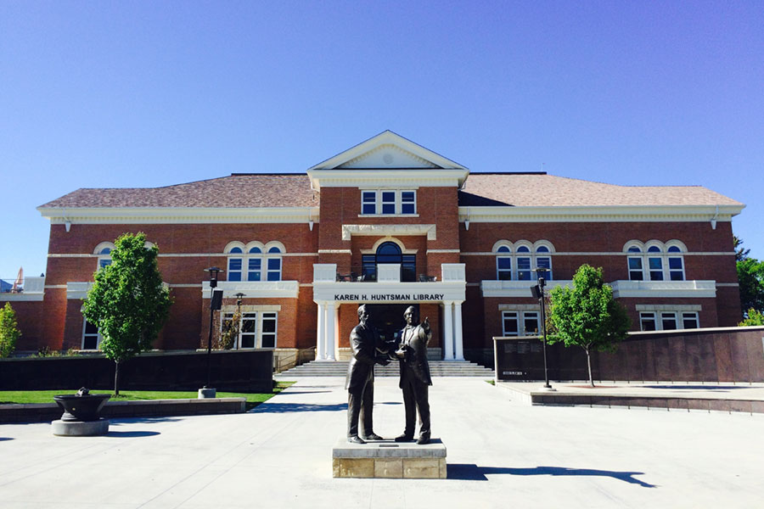

Standard 2: Governance, Resources, and Capacity

2020 Year Seven Self-Evaluation Report

Executive Summary of Eligibility Requirements 2 and 3
Snow College articulates its educational purpose in a mission statement and identifies core themes that represent distinct elements of that mission. In the examination of its purpose, characteristics, and expectations, the College defines the parameters of mission fulfillment and identifies the acceptable achievement of mission fulfillment.

Eligibility Requirement 2: Authority
The institution is authorized to operate and award degrees as a higher education institution by the appropriate governmental organization, agency, or governing board as required by the jurisdiction in which it operates.
Founded in 1888 by local citizens, Sanpete Stake Academy was later named Snow College (1923) and is one of the oldest junior colleges west of the Mississippi. The college was transferred from The Church of Jesus Christ of Latter-day Saints to become one of eight stand-alone institutions in the Utah System of Higher Education in 1931 and is accredited separated from those other institutions (https://le.utah.gov/xcode/Title53B/53B.html, Chapter 2, Section 101).

Eligibility Requirement 3: Mission and Core Themes
The institution’s mission and core themes are clearly defined and adopted by its governing board(s) consistent with its legal authorization and are appropriate to a degree-granting institution of higher education. The institution’s purpose is to serve the educational interests of its students and its principal programs lead to recognized degrees. The institution devotes all, or substantially all, of its resources to support its educational mission and core themes.
Snow College mission and core themes are clearly defined and were approved in their current form by the Snow College Board of Trustees on February 16th, 2011 and accepted by the Utah State Board of Regents July 15th 2011 (consistent with policy R121). Consistent with Regent policy R500 et seq., and supported by the College’s Strategic Plan (2015, 2018), and the College’s Strategic Enrollment Management Plan (2017), the institution devotes all, or substantially all, of its resources to support its educational mission and core theme development, as required by NWCCU.

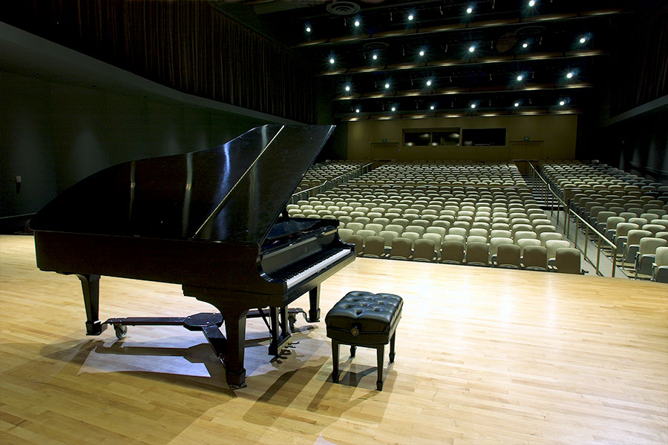

Standard 2: Resources and Capacity

2020 Year Seven Self-Evaluation Report

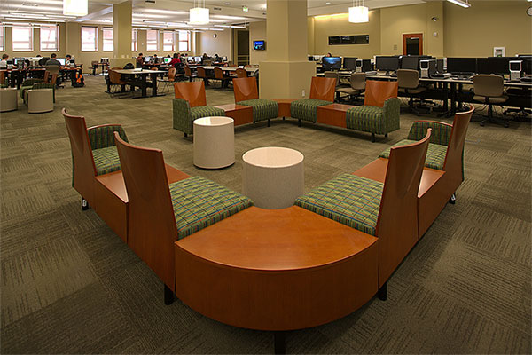

Executive Summary of Eligibility Requirements 4-21
By documenting the adequacy of its resources and capacity, Snow College demonstrates the potential to achieve the intended outcomes of its programs and services (whenever and however delivered), accomplish core theme objectives, and realize its mission. Snow College’s governance and decision-making structures enable the institution to regularly review and revise policies and procedures that promote the effective management and operation of the institution.
Requirement 4. Operational Focus and Independence
The institution’s programs and services are predominantly concerned with higher education. The institution has sufficient organizational and operational independence to be held accountable and responsible for meeting the Commission’s standards and eligibility requirements.
Snow College is a part of the Utah State System of Higher Education and operates under the standards and guidelines set by USHE and its Board of Regents (see policies R312 and R201). Snow College has been accredited as an institution for higher education since 1953. Snow College’s organizational structure, described in Standard 2.A.10-11, provides sufficient operational independence for the college to be held accountable for meeting the Commission’s standards.
Requirement 5: Non-Discrimination
The institution is governed and administered with respect for the individual in a nondiscriminatory manner while responding to the educational needs and legitimate claims of the constituencies it serves as determined by its charter, its mission, and its core themes.
Snow College adheres to formal USHE policy R801 which provides for the “equal opportunity and diversity, and nondiscrimination in employment and educational programs, services and activities on the basis of race, color, religion, national or ethnic origin, gender, pregnancy, childbirth, pregnancy-related conditions, age, disability, veteran status, or otherwise provided by law” (see Snow College policies, 300-310). In addition, Snow College has a full-time Multicultural/Diversity officer and a full-time Risk Management/Title IX officer operationally separate from Human Resources, who help ensure that all policies are equitably and sensitively applied.
Requirement 6: Institutional Integrity
The institution establishes and adheres to ethical standards in all its operations and relationships.
A described in Standard 2.A.22, Snow College faculty, staff and students are subject to policies and procedures indicative of a professional, respectful, and honest community. The College has well-defined rules regarding the academic freedoms of faculty and students and policies that safeguard the fair and equitable treatment of employees. Snow College provides accurate information regarding policies, programs, and services. It prohibits discrimination and provides equal opportunity, equal access, and a safe environment.
Requirement 7: Governing Board
The institution has a functioning governing board responsible for the quality and integrity of the institution and for each unit within a multiple-unit institution to ensure that the institution’s mission and core themes are being achieved. The governing board has at least five voting members, a majority of whom have no contractual or employment relationship or personal financial interest with the institution.
The Utah System of Higher Education (USHE) is governed by the Board of Regents and is comprised of Utah’s eight public colleges and universities. The CEO of USHE is the Commissioner of Higher Education. The Utah Legislature grants the Board of Regents the power to control, manage, and supervise USHE. The Board of Regents selects and holds ultimate accountability over the college president. In addition, the Board of Regents sets policy, reviews college programs and degrees, approves institutional missions (and core themes), and submits a unified higher education budget request to Utah’s Governor and the Utah State Legislature each year. The Board of Regents is represented by 17 Utah citizens, all appointed by the Governor: 8 at-large; 8 previous institutional trustees with representation from each USHE institution, and 1 student regent representative.
The Snow College Board of Trustees is a governing body of Snow College and functions under the direction of the Board of Regents. The Board of Trustees consists of ten appointed members and acts in behalf of Snow College in performing such duties, responsibilities, and functions as authorized and delegated by the Board of Regents.
Requirement 8. Chief Executive Officer
The institution employs a chief executive officer who is appointed by the governing board and whose full-time responsibility is to the institution. Neither the chief executive officer nor an executive officer of the institution chairs the institution’s governing board.
The President of Snow College is appointed by and serves at the pleasure of the Board of Regents. The President’s full-time responsibility is to the college. Working with the Snow College Board of Trustees, the Board of Regents annually evaluates the president’s performance. Neither the President not any Executive Officer of the college chairs the Board of Trustees or the Board of Regents.
Requirement 9. Administration
In addition to a chief executive officer, the institution employs a sufficient number of qualified administrators who provide effective leadership and management for the institution’s major support and operational functions and work collaboratively across institutional functions and units to foster fulfillment of the institution’s mission and the achievement of its core themes.
The college’s operations are divided into five main areas: Academic Affairs, Finance and Administrative Services, Student Success, Athletics, and Development, with each overseen by an appropriate qualified administrator (either a vice president or a director) who reports to the President. Three executive level leadership groups—the President’s Cabinet, the College Council, and the College Leadership Council—meet regularly to discuss institutional initiatives, coordinate their work, approve and/or revise college policy, and advise the President and Vice President of Academic Affairs (who also serves as the Provost) regarding the accomplishment of Snow College’s mission and core theme objectives.
Requirement 10. Faculty
Consistent with its mission and core themes, the institution employs and regularly evaluates the performance of appropriately qualified faculty sufficient in number to achieve its educational objectives, establish and oversee academic policies, and ensure the integrity and continuity of its academic programs wherever offered and however delivered.
Snow College maintains a highly qualified core of faculty to meet institutional goals. Of the 147 full-time faculty members, 85% are either tenured or tenure eligible. There are 22 faculty members who are classified as professional track, meaning they have multi-year contracts but are not on a tenure track. As of fall 2020, Snow College maintained a 20:1 ratio of students to full-time faculty. Snow College’s Faculty Workload policy defines the basic full-time workload to maintain high standards of excellence in teaching. All full-time faculty are evaluated annually. Faculty eligible for tenure or rank advancement undergo a comprehensive evaluation and recommendation from three-member faculty evaluation teams.
Requirement 11. Educational Program
The institution provides one or more educational programs which include appropriate content and rigor consistent with its mission and core themes. The educational program(s) culminate in achievement of clearly identified student learning outcomes, and lead to collegiate-level degree(s) with degree designation consistent with program content in recognized fields of study.
As of fall 2020, Snow College offers 2 baccalaureate degree programs, two general associate degrees, five specialized associate degrees, 15 associate of applied science degrees, 13 certificates of completion, 27 certificates of proficiency, and two awards. Each degree program has clearly identified program learning outcomes that are published on Snow College’s assessment site and linked to the Snow College Catalog. Program learning outcomes are mapped to program curriculum and evaluated annually at the end of spring semester. All degree programs are subject to period review every five years pursuant to Board of Regents policy, R411 (Cyclical Institutional Program Reviews), that includes a comprehensive self-study and visit by a qualified expert from a peer institution or related industry and an internal professional not associated with the program. The external review team assess the program with respect to program learning outcomes and recognized field of student best practices. The results of each program review are reported to the Snow College Board of Trustees and the Board of Regents. In addition, four programs (Music, Theatre, Business, and Nursing) have specialized accreditation by accrediting agencies in the associated discipline.
Requirement 12. General Education and Related Instruction
The institution’s baccalaureate degree programs and/or academic or transfer associate degree programs require a substantial and coherent component of general education as a prerequisite to or an essential element of the programs offered. All other associate degree programs (e.g. applied, specialized, or technical) and programs of study of either 30 semester or 45 quarter credits or more for which certificates are granted contain a recognizable core of related instruction or general education with identified outcomes in the areas of communication, computation, and human relations that align with and support program goals or intended outcomes. Bachelor and graduate degree programs also require a planned program of major specialization or concentration.
A total number of 32 credits is required to complete Snow College’s General Education Core Curriculum. General Education completion is required for the Associate of Arts, Associate of Science, and all specialized associate degrees. The 32 required credits are represented as follows: six writing, three quantitative literacy, three American institutions, three fine arts, three humanities, three social science, at least three physical science, and four life science (including a lab requirement). Students seeking the Associate of Science degree must complete three credits of science inquiry; students seeing the Associate of Arts degree must complete 10 credits of foreign language. Upon completion of Snow College’s General Education Core Curriculum, students are awarded a General Education Certificate of Completion. The General Education Core Curriculum has defined and published learning outcomes. These learning outcomes are evaluated periodically on a five-year cycle by faculty under the Assistant Vice President of Academic Affairs, who also serves and the General Education Director.
Requirement 13. Library and Information Resources
Consistent with its mission and core themes, the institution maintains and/or provides access to library and information resources with an appropriate level of currency, depth, and breadth to support the institution’s programs and services wherever offered and however delivered.
The Snow College Library system provides digital and/or electronic access to 101 databases and a circulation of 78,769 materials. Working with the state of Utah’s inter-library network Snow College received 281 interlibrary loans/document and provided 530 similar materials to other libraries. Currently, there are 7,543 media sources, 775 serials, and 57,726 books physically located on the Ephraim or Richfield campuses. The Ephraim campus library also houses access to a variety of computers and software applications in addition to two 3-Dimensional printers and a large-format commercial printer. Librarians provide individual and group information literacy instruction to students, faculty and staff each year and supply point-of-need help through web pages, guides, printed materials, email, phone, and in-person assistance. Library staff members also assist and provide students, faculty and staff access to technology and media resources and tools required for emerging 21st-century literacies.

Requirement 14. Physical and Technological Infrastructure
The institution provides the physical and technological infrastructure necessary to achieve its mission and core themes.
Snow College has two campuses: one located in Ephraim, Utah; the other located approximately 70 miles away in Richfield, Utah. The Ephraim campus is comprised of 28 academic or administrative buildings and 8 residence halls, representing 923,548 square feet. The Ephraim campus has 70 classrooms that seat approximately 6,000 students and 65 teaching laboratories that accommodate 4,000 students. The Richfield campus is represented by three main buildings and 285,987 square feet. This campus has 14 classrooms that seat 600 students and 11 teaching laboratories that serve 340 students. The physical infrastructure of both campuses varies in age from older to state-of-the art. The technology infrastructure primarily includes fiber optic connections between buildings and most floors. Both campuses have a dedicated wireless network available to faculty, staff, students and campus guests. There is also brocade routing and switching and global backup solutions for campus network environments. The Richfield campus serves as the data warehouse/backup security center for the state of Utah. While there is continuing need to plan for growth and accommodate the growing technological needs of students, faculty, and staff, Snow College provides the physical and technological infrastructure needed to achieve its mission in excellence, innovation, and community engagement.
Requirement 15. Academic Freedom
The institution maintains an atmosphere in which intellectual freedom and independence exist. Faculty and students are fee to examine all knowledge appropriate to their discipline or area of major study as judged by the academic/educational community in general.
Consistent with the institution’s mission and core themes, Snow College promotes an atmosphere in which independent thought and the freedom of expression in the pursuit of the dissemination of knowledge, understanding, and learning are protected. Policies regarding Academic Freedom are clearly stated, published, and accessible: Board of Regents rule, R481: Academic Freedom, Professional Responsibility, Tenure, Termination, and Post-Tenure Review (specifically, R481-3.3, 3.3.1, 3.3.2, and 3.3.3), Snow College Policy #125: Free Speech; Snow College Policy #401: Faculty Professional Responsibility & Standards of Conduct and Snow College Catalog: Academic Policies and Standards. Faculty and students are encouraged to conduct research, participate in conferences, and discuss intellectual topics in the classroom as well as engage in professional, intellectual and/or citizen and community-oriented exchanges in support of the common good.
Requirement 16. Admissions
The institution publishes its student admissions policy which specifies the characteristics and qualifications appropriate for its programs, and it adheres to that policy in its admissions procedures and practices.
Admission requirements for all students are published on the Office of Admissions website. Snow College is an open enrollment institution. As such, the institution does not have admissions deadlines, but does post enrollment deadlines, which are the first day of classes for each academic semester/term including mid-semester or block classes. Admissions to bachelor’s degree programs are posted on the specific program websites and students seeking those degrees are informed of distinct admissions requirements during advising sessions. Snow College adheres to these requirements in its admissions procedures and practices.
Requirement 17. Public Information
The institution published in a catalog and/or online current and accurate information regarding its mission and core themes; admission requirements and procedures; grading policy; information on academic programs and courses; names, titles and academic credentials of administrators and faculty; rules and regulations for student conduct; rights and responsibilities of students; tuition; feeds, and other program costs; refund policies and procedures; opportunities and requirements for financial aid; and the academic calendar.
Snow College publishes digitally and in limited hard copy an Academic Catalog that is updated annually. The catalog includes the college’s mission and core themes; admission requirements and procedures; grading policy; information on academic programs and courses; names, titles and academic credentials of administrators and faculty; rules and regulations for student conduct; rights and responsibilities of students; tuition; feeds, and other program costs; refund policies and procedures; opportunities and requirements for financial aid; and the academic calendar. In addition, students may find the same information via dedicated web locations using external and the institutional internal web search engines.
Requirement 18. Financial Resources
The institution demonstrates financial stability with sufficient cash flow and, as appropriate, reserves to support its programs and services. Financial planning reflects available funds, realistic development of financial resources, and appropriate risk management to ensure short-term solvency and long-term financial sustainability.
As a member of the Utah System of Higher Education, Snow College is funded by allocations from the Utah State Legislature. Fiscal year 0708 marked Snow College’s highest allocation from the state legislature--$20,298,700. Recession-fueled budget cuts and a slow turn-around to the economy reduced Snow College’s state funding by up to -15%. Beginning FY 1314, the state of Utah dedicated increased funding to higher education, and by FY 1516, Snow College received $20,057,400 tax dollars, which was ($241,300) short of the FY 0708 peak. Only 65% of Snow College’s operating budget is comprised of state tax dollars. Tuition revenues along with the re-allocation of programs, general fund resources, grant acquisition, and capital campaigns have compensated for the lack of state funding.
First established in 2013, higher education Performance Funding was a one-time basis subsidy, making it a challenge for institutions to fund ongoing initiatives that drive improved performance. In the 2017 legislative session, a revised performance funding, outcomes-focused model was passed that established the Performance Funding Restricted Account (S.B. 117—Higher Education Performance Funding by Millner/Wilson). The account is funded from 14% of the estimated revenue growth from targeted jobs in FY 2019, and 20% in FY 2020 and thereafter. Starting in 2018, future funding to his account is dependent on revenue growth of Utah’s targeted “5-Star” jobs as defined by the Department of Workforce services. Also, in 2018, the Utah System of Technical Colleges (UCAT) will be granted 10% of the funding increase from the Performance Funding Restricted Account. The Legislature determines to send those funds to institutions that have met the required performance metrics set by the Board of Regents.
All USHE institutions can submit a budget request to the Utah Legislature via the Utah Board of Regent’s Commissioner. Institutional requests along with performance funding metrics help determine USHE’s annual funding and distinct institutional disbursements. Snow College consistently prioritizes its funding requests according to immediate and three-to-five year operational and capital project needs (see Utah Code 53B).
Typically, Snow College receives an annual disbursement of funds from the State of Utah at the beginning of each fiscal year. Tuition and fee revenues are received August/September for the fall semester; January/February for the spring semester; and April/May for summer term schedules. The college monitors all its accounts for cash balance on a monthly basis.
Snow College has well-established financial planning linked to the college’s mission and core themes. This is reflected in the 2012-2013 strategic plan and Snow College’s Program Prioritization report. Snow College Strategic Enrollment Management plan necessitates short-term and long-term financial planning for internal resource allocation, marketing, and leveraged scholarship dollars that are driven by state tuition and fee waivers as well as private donor contributions. Short-term/annual financial planning is informed by enrollment analyses and projections performed by Snow College, the Utah System of Higher Education, and the Governor’s Office of Planning and Budget. Financial planning is designed to accommodate projected enrollment and target population dynamics as well as external elements that potentially compete for tuition and fee amounts (i.e. out-of-state online education). Annual and extended budgets are strategically designed to accommodate these projected trends. In all financial planning, operational and capital requirements are examined.
Snow College’s financial planning placed strong support on academic instruction and academic support activities, which is indicative of the institution’s tradition of excellence, culture of innovation, and community engagement core themes. The college has increased its reliance on tuition and fee collections versus state appropriations (formerly 78% dependence, now 65%) without implementing a drastic tuition and fee burdens on current and potential students. Snow College consistently has the most affordable tuition and fee rates among all USHE institutions. In addition, the institution has placed an emphasis on private gifts and grants; has diversified endowment funds to increase endowment dollars (up from $5.6 million in 2015 to over $8 million in 2018); and has conservatively managed debt.
Snow College has averages $XXXX million in operational carry forward in the Educational and General (E & G) budget over the past 10 years. Reserved from operations have also been established for auxiliary and service enterprises over the same time frame.
Requirement 19. Financial Accountability
For each year of operation, the institution undergoes an external financial audit, in a reasonable time frame, by professionally qualified personnel in accordance with generally accepted auditing standards. Results from the audit, including findings and management letter recommendations, are considered in a timely, appropriate, and comprehensive manner by the administration and governing board.
By policy, (Utah Code 53B, Regent Policy R561), the Utah State Auditor performs an independent audit of Snow College’s finances at least annually. An audit committee representing members of Snow College’s Board of Trustees and qualified financial professionals review the audits at least annually. In addition, all USHE institutions are required to issue an annual financial report for each fiscal year using generally accepted accounting principles for college and universities. These annual reports are filed with the Office of the Commissioner for Higher Education for the use of the Board of Regents and associated staff upon publication.
Requirement 20. Disclosure
The institution accurately discloses to the Commission all information the Commission may require to carry out its evaluation and accreditation functions.
Snow College is committed to institutional integrity and transparency. The college makes every effort to be accurate in all disclosures and will continue to share all information to NWCCU requests.
Requirement 21. Relationship with the Accreditation Commission
The institution accepts the standards and related policies of the Commission and agrees to comply with these standards and policies as currently states or as modified in accordance with Commission policy. Further, the institution agrees that the Commission may, at its discretion, make known the nature of any action, positive or negative, regarding the institution’s status with the Commission to any agency or members of the public requesting such information.
Snow College accepts the standards and related policies of the Commission and agrees to comply with those standards currently states or as modified in accordance with Commission policy. This includes the right of the Commission to disclose the institution’s status to other agencies and/or members of the public.

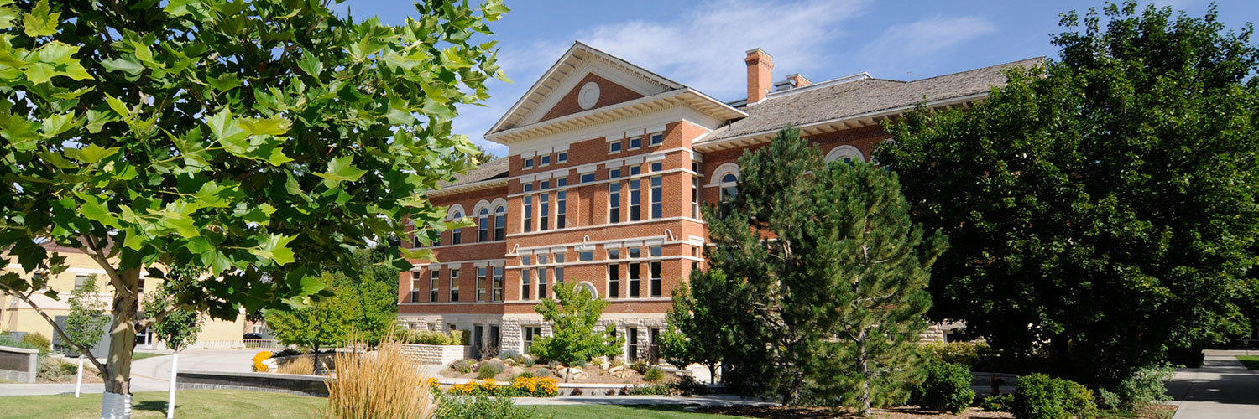

Standard 2A - Governance

2.A.1. The institution demonstrates an effective and widely understood system of governance with clearly defined authority, roles, and responsibilities. Its decision-making structures and processes make provision for the consideration of the views of faculty, staff, administrators, and students on matters in which they have direct and reasonable interest.
Snow College is a member of the Utah System of Higher Education (USHE). The exclusive control and administration of the college are vested in an appointed Board of Regents according to Utah Code 53B-1-103. Standards 2.A.2 and 2.A.4 describes the Regents’ structure and functioning. The Commissioner of Higher Education serves as the chief executive office of Utah’s system of higher education and is responsible for system leadership, strategic development, and implementation of Regent policies. The institutional presidents report directly to the Commissioner and the Board of Regents.
Snow College’s governance structure is well-defined and effectively sustains the various functions of the institution. The President is the chief executive officer of the institution and is accountable for the leadership and direction of the college. Details of the system of leadership for the college are outlined in section 2.A.9.
Snow College has nine-member board of trustees that serve to advise the President on matters related to the institution. The President’s authority to develop policy for the institution and prepare initiatives for response by the Board of Trustees are subject to approval by the Board of Trustees (R220, section 4.4).
Regent policy R312 outlines the organizational and administrative structure of the institution, including the mission statement, and the general policies regarding faculty, student admission, and support services. The Snow College administrative manual has established policies, procedures and guidelines for specific tasks. These policies, procedures and tasks are also broadly communicated on the Snow College website at https://www.snow.edu/general/policies/index.html. Snow College policy 101 outlines the process proposing new policy or requesting updates to existing policy through College Council, which advises the President on proposals it has received.
Snow College has a 13-member Faculty Senate charged with representing the faculty in the policy-making process of the College. A senior and junior faculty are each elected from Snow College’s five academic divisions. All senators must be full-time faculty with at least one having tenure and the equivalent of seven years of teaching experience at Snow College. The other faculty senators must be full-time faculty with at least one year of teaching experience on the Richfield or Ephraim campus. The Faculty Association President is a recognized as a voting senator. A non-voting adjunct representative is appointed by the Faculty Senate, and a non-voting student representative is selected by the student government. The Senate meets monthly and can hold additional meetings upon request and the Faculty Senate President/Chair meets regularly with the President and Vice President of Academic Affairs. The Faculty Senate website has links to the mission, governing documents, bylaws, procedures, and lists standing committees.
2.A.2. In a multi-unit governance system, the division of authority and responsibility between the system and the institution is clearly delineated. System policies, regulations, and procedures concerning the institution are clearly defined and equitably administered.
The Utah System of High Education includes 8 public colleges and universities: two community colleges, four comprehensive institutions, and two research universities. Snow College functions in a system of governance that is clearly described in Utah State statute, Utah Board of Regents policies, and institutional policies. These statutes and policies define the authority, responsibilities, and relationships between Snow College’s two main governing bodies: the Utah State Board of Regents and the Snow College Board of Trustees.
Utah Code (Title 53B-1-103) stipulates that Utah State Board of Regents “shall control, manage, and supervise the institutions of higher education” in a manner that provides strategic leadership and links system capacity to the economy and workforce needs of the state of Utah. The Regents delegate certain powers and authorities to localized boards of trustees and presidents (Regent Policy R220). Utah Code defines the duties and responsibilities of the Board of Regents, which include
- System Efficacy: Directs planning involving institutional mission and roles, facilitates program articulation between institutions, and enhances the efficacy of the system through well-defined goals and established metrics on institutional performance.
- System Leadership: Appoints presidents, evaluates the performance of presidents, and determines the retention or transition of presidents in consultation with respective boards of trustees.
- System Reporting: submits system and institutional budgets to the governor and state legislature, approves tuition and fee schedules, provides system reporting to the governor, legislature, and federal agencies using regularly supplied institutional data, and advocates higher education needs with the state legislature.
The Commissioner of Higher Education serves as the chief executive officer of the board, and the board elects a member to serve as chair. The appointment of a new chair every two years provides opportunities for the board to review its performance and make necessary revisions.

2.A.3 The institution monitors its compliance with the Commission’s Standards for Accreditation, including the impact of collective bargaining agreements, legislative actions, and external mandates.
Snow College monitors is compliance with NWCCU Standards for Accreditation. This is achieved by sending representatives to NWCCU workshops, annual meetings, and regular reporting to NWCCU. Dr. Steve Hood, Vice President for Academic Affairs, is the Accreditation Liaison Officer at the college. Dr. Beckie Hermansen, Director for Institutional Research and Effectiveness, serves as and NWCCU evaluator and oversees all the NWCCU reporting activities, including annual reports, accreditation report preparation, and evaluation site team member visits. Snow College does not have any collective bargaining agreements.
Governing Board
2.A.4 The institution has a functioning governing board consisting of at least five voting members, a majority of whom have no contractual, employment, or financial interest in the institution. If the institution is governed by a hierarchical structure of multiple boards, the roles responsibilities, and authority of each board—as they relate to the institution—are clearly defined, widely communicated, and broadly understood.
The Utah State Board of Regents is the governing body for the Utah System of Higher Education (USHE). The Utah Legislature grants it power to control, manage, and supervise USHE. The Board’s major responsibilities including “selecting and evaluating institutional presidents, setting policy, reviewing programs and degrees, approving institutional missions, and submitting a unified higher education budget request to the Governor and State Legislature” (https://ushe.edu/board-of-regents/about-the-board/). The Board of Regents is represented by 8 at-large members and 8 previous institutional trustees (with representation from each institution), and one selected student regent. All 16 board members are appointed for six-year terms and the student regent served a one-year term. Voting board members are appointed by the Governor and approved by the Utah State Senate.
In addition to the Board of Regents, each institution in the Utah System of Higher Education has a Board of Trustees that operates with duties delegated by Board of Regent policy (R120, section 3.3.4). Specifically, institutional boards of trustees may “enact bylaws for its own government as it deems necessary, including provision for regular meetings of the institutional Board of Trustees, consistent with Regents policies.”
Snow College’s Board of Trustees is the governing body of Snow College, under the direction of the State Board of Regents. The Board of Trustees acts on behalf of Snow College in performing such duties, responsibilities, and functions as authorized and delegated by the Board of Regents. The bylaws of the Snow College Board of Trustees outline the membership and duties of the board as follows:
- Membership consists of ten persons, eight of whom are appointed by the Governor with the consent of the Utah State Senate. The President of the Snow College Alumni Association serves as the ninth members, and the President of the Associated Students of Snow college serves as the tenth member of the Board (Utah Code 53B-2-104).
- The eight appointed members serve four-year terms, four expiring on June 30 of each odd-numbered year. The two ex officio members serves for the terms of their respective offices.
- The principal sources of Board of Trustees authority are (a) statues enacted by the State Legislature and (b) bylaw of the Utah State Board of Regents and (c) policies of Snow College.
Statutory Powers:
- The Board shall act in behalf of Snow College in performing such duties, responsibilities, and functions as provided by law and as may be specifically authorized and delegated to the Board by the Board of Regents.
- The Board shall act in behalf of Snow College in facilitating communication between Snow College and the community; in assisting, planning, and implementing, and executing fund-raising and development programs; and in strengthening alumni and community identification with the institution’s traditions and goals.
- The Board shall have the authority to adopt a Policy and Procedure Guide and other rules and regulations necessary or convenient and desirable for the efficient and well-ordered administration of the institution.
- The Board shall have the authority to establish such standing and ad hoc committees as it deems necessary to properly fulfill its responsibilities.
- Unless reserved by or to the Board of Regents, the Board shall have the authority to approve the actions of the President of the College regarding personnel issues and policies, institutional organization and leadership, the direction of student instruction, admission, and classification, the provision of administrative committees over specified institutional matters, and the publication of institutional standards regarding education policy and programs.
- The Board shall assist the President in carrying out his/her responsibilities (1) for the protection, repair, and maintenance of all property, both real and personal, of Snow college and (2) for the protection, education, welfare and general well-being of all persons admitted and enrolled at Snow College or otherwise entered upon the premises of the institution, under such rules and regulations as the President may establish with the approval of the Board.
- The Board shall select persons to be awarded honorary degrees by Snow College in recognition of outstanding achievement or distinctive public service.
- The Board shall approve all candidates for earned degrees and diplomas authorized by law and the Utah State Board of Regents which are conferred by Snow College.
2.A.5 The Board acts only as a committee of the whole; no member or subcommittee of the board acts on behalf of the board except by formal delegation of authority by the governing board as a whole.
The Regents hold approximately six public meetings (located at the different USHE campuses) during which they plan, prioritize, and approve operations, initiatives, programs, and services at the state institutions. All actions are taken as a committee of the whole. Board of Regent meetings are public meetings that are livestreamed online and all meeting agendas and minutes are available on the Board of Regents website at https://ushe.edu/board-of-regents/meeting-schedule-and-agendas/. No member or subcommittee of the Regents my act on behalf of the Regents without formal delegation.
The Snow College Board of Trustees and committees of the Trustees meet monthly according to a published schedule. Special meetings may be convened by the chairperson, by six members of the Board acting jointly, or by the college President. No member or subcommittee of the Board of Trustees may act on behalf of the Regents without formal delegation.
2.A.6. The board establishes, reviews regularly, revises as necessary, and exercises broad oversight of institutional policies, including those regarding its own organization and operation.
The Bylaws for the Snow College Board of Trustees grant the Trustees responsibility for approving institutional policies, both regular and emergency, as set by the president according to Utah Code authority specific to the organization of faculty, students, and employee organizations; the instruction, examination, and classification of students; and the “necessary and proper exercise of powers and authority not specifically denied to the institution of higher education or the institution of higher education’s administration, faculty, or students by the board or by law, to ensure the effective and efficient administration and operation of the institution of higher education consistent with the statewide master plan for higher education” (Utah Code 53B-2-106 (1)(a)).
2.A.7. The board selects and evaluates regularly a chief executive officer who is accountable for the operation of the institution. It delegates authority and responsibility to the CEO to implement and administer board-approved policies related to the operation of the institution.
The Utah State Board of Regents appoints the Snow College president, who is regularly evaluated according to Regent policy R209: Evaluation of Presidents. Each college or university president is comprehensively evaluated following the first year of his or her tenure and every four years thereafter. Comprehensive evaluations occur during the spring semester. Evaluations on shorter intervals may be requested by the Regents or the institutional president. The formal appraisal of each president involves confidential interviews from a broad range of vice presidents, deans, academic and administrative department heads, faculty, students, community leaders, alumni and local and state government leaders. Consideration is also given to leaders or representatives from the Faculty Senate, Board of Trustees, and the Board of Regents. The president is evaluated using the following criteria:
- The vision, mission, strategic goals (short-term and long-term), and action plans to achieve those goals as well as mission fulfillment.
- The fiscal health of the institution according to budgetary priorities and the efficient and effective use of institutional resources.
- Academic/institutional leadership and planning that promotes scholarship, intellectual diversity, academic freedom, teaching quality, course rigor, regular program review, and program outreach supportive of economic development.
- The morale of faculty and staff and the nature of the work environment, including the enforcement of personnel policies regarding employee performance and corrective action.
- His or her ability to assume responsible decision-making associated with a full understanding of issues, the interrelated nature of the various business and academic functions of the institution, and the ability to proactively and collaborative seek solutions.
- His or her ability to establish positive relationships with external communities that includes but is not limited to local civic leaders, business/industry executives, other college presidents, legislators, alumni, and donors.
- The establishment of a vibrant, challenging, safe, supportive, and positive environment for the institution’s students.
Regent Policy 201: Presidents’ Responsibility to the System, the Assigned Institution, and for Legislative Relations details the duties and responsibilities of the college president. As an executive officer, the president is accountable to the Utah State System of Higher Education as well as to the respective institution. “It is the duty of the Presidents under the law to support eh State Board of Regents’ decisions including, but not limited to, budget, finance, facilities, planning, roles, curriculum, programs, and System-wide administrative policies.” Presidents must also maintain effective informational liaison with members of the Utah Legislature such that they are fully informed of the problems and accomplishments of each institution. Utah Code 53B-2-106 further describes the duties of the President to establish institutional standards; appoint faculty, staff, and administrative personnel, prescribe their duties, and determine their compensation; provide for the organization of faculty and administration; establish a prescribed system of instruction and examination, admission, and classification of students; enact rules and/or policies for the effective operation of Snow College, which may or may not include the appointment of administrative, faculty, student, staff, and joint committees.
2.A.8 The board regularly evaluates its performance to ensure its duties and responsibilities are fulfilled in an effective and efficient manner.
Regent Policy 123: Board Self-Evaluation and Orientation requires the Board of Regents conduct annual self-assessments on its performance as a governing and policy making body. The aim of this self-evaluation is to strengthen the Board’s effectiveness. This policy “is also intended to meet relevant accreditation standards for Utah’s public colleges and universities.”
Leadership and Management
2.A.9 The institution has an effective system of leadership staffed by qualified administrators with appropriate levels of responsibility and accountability, who are charged with planning, organizing, and managing the institution and assessing its achievements and effectiveness.
Snow College has three divisions: Academic Affairs, Student Success, and Finance and Administrative Management. President Cook appoints vice presidents to oversee each division typically through a screening/hiring process and approved by the Snow College Board of Trustees. The screening/hiring process ensures that each position is staffed by personnel who have the education, qualification, work experience, and ethnical conduct to effectively fulfill the role. Job descriptions are posted on the Snow College Human Resources website. All vice presidents are evaluated annually by the president using performance feedback from direct reports, peers, and external constituents.
All hiring decisions are governed by the Affirmative Action/Equal Employment Opportunity policy and reviewed by the institution’s AA/EEO officer.
These vice presidents along with the Vice President for Academic Affairs, the Vice President for Enrollment Management, and two Assistants to the President (representing the Ephraim and Richfield campuses) serve on the President’s Cabinet. As an advisory council to the president, the Cabinet provides representation and communication among the three main institutional divisions as well as with other internal consultative or constituent groups. The President’s Cabinet meets weekly or as needed for timely decision-making.
President Cook has established other direct reports representing the offices of Internal Audit, Alumni and Development, Marketing, Economic Development, and Athletics. For the 2019-2020 academic year, an external consultant was hired to develop a plan for competency-based education.
2.A.10 The institution employs an appropriately qualified chief executive officer with full-time responsibility to the institution. The chief executive officer may serve as an ex officio member of the governing board but may not serve as its chair.
Snow College’s president, Dr. Brad Cook was appointed by the Utah State Board of Regents in May 2019 as the 17th president of Snow College. President Cooks previous experience was as Provost at Southern Utah University, President of the Abu Dhabi Women’s College in the United Arab Emirates, Vice President of College Relations and later Vice President of Academic Affairs at Utah Valley State College. President Cook has full-time responsibilities to the college and does not serve as a member of the Snow College Board of Trustees.
2.A.11 The institution employs a sufficient number of qualified administrators who provide effective leadership and management for the institution’s major support and operational functions and work collaboratively across institutional functions and units to foster fulfillment of the institution’s mission and accomplishment of its core theme disciplines.
College Council
The primary purpose of College Council is to approve and revise policy. The Council is chaired by the college president and staffed by the president’s assistant. Council membership includes representatives from faculty, staff, students, and administration to create a shared governance body for the college as follows:
- One academic dean (selected by the Deans Council)
- Faculty Senate President
- Four faculty members (selected by the Faculty Senate)
- Staff Association President
- Staff At-Large representative
- Student Success Center representative
- Student Body President
- Vice President for Academic Affairs
- Vice President for Finance & Administrative Services
- Vice President for Student Success

College Council also works to improve communication and the dissemination of information campus wide. College Council meets every other month with agendas and meeting minutes posted at https://www.snow.edu/offices/president/council.html.
Faculty Involvement
The Snow College Faculty Senate represents the faculty in the policy-making process of Snow College. It is a partner with the administration, Board of Trustees, and staff in promoting the mission of the College in the areas of academic freedom, curriculum and program development, degree and certificate requirements, academic standards, faculty advancement, professional development, institutional planning, and budget development. The following faculty committees are assembled under the direction of the Faculty Senate:
- Advancement & Tenure
- Curriculum, including the General Education curriculum sub-committee
- Faculty Development
- Global Engagement
- Honors Program
- Library
- Professional Track
- Service Learning
- Teaching and Technology Center
Faculty Senate membership consists of two full-time faculty members (a junior faculty member and a senior faculty member) from each academic division. Snow College has five academic divisions representing the areas of Business and Applied Technologies, Fine Arts & Communications, Humanities, Natural Science & Mathematics, and Social Science. Senior faculty members are tenured or have the equivalent of seven years teaching experience at Snow College. Junior faculty members have taught on either the Richfield or Ephraim campus for one full year. The Faculty Association President is a voting member of the Faculty Senate. The Faculty Association President and all members of the Faculty Senate are elected by their faculty peers. An adjunct faculty representative and a student representative are appointed, non-voting positions on the Senate. Faculty Senate representatives serve for three years on alternating terms.
In addition to the Faculty Senate and respective Senate committees, there are administrative standing committees such as the Deans Council and ad hoc committees that allow faculty to participate in institutional governance. These committees report to the Vice President for Academic Affairs (see Duties of Deans and Department Chairs document in Appendix XXXX).
Staff Involvement
The Snow College Staff Association (SCSA) represents all part-time and full-time staff at Snow College to the administration on matters of equality, benefits, salaries, training, and professional development. The SCSA Executive Council is comprised of the past president, current president, president-elect, and chairs to each of the SCSA committees, each of whom are elected to serve at two-year term. The Executive Council also promotes open communication and collaboration with the Faculty Senate, administration, and the college community.
Several administrative departments within the college are led by senior level administrators and/or directors. These positions report to their respective vice president and are responsible to seek input and discuss relevant issues with members of their division.
Administrators below the level of the vice president are evaluated regularly for formative purposes. The evaluation of academic deans and department chairs is guided by policy.

Student Involvement
Student involvement with institutional governance occurs through multiple channels. Student body officers represent either the executive or legislative branches of student government. The executive branch has a generally elected President and Vice President, an appointed Executive Assistant, an appointed clubs/organization representative, and ten other appointed Advocates responsible for student event programming and marketing. The legislative branch is comprised of five elected student Advocates representing the areas of academics, inclusion and diversity, services, arts and lectures, and athletics. The Student Body President serves as a non-voting member on the Snow College Board of Trustees, College Council and the Snow College Student Fee Advisory Board. The Student Body President also represents Snow College students to the Utah System of Higher Education as a member of the Utah Student Association. Other student body officers serve on several institutional committees such as the Alumni Board, Deans Council, Strategic Enrollment Management Committee, and Faculty Senate.
Alumni and Community Involvement
Snow College enjoys collaborative relationships and seeks input from a variety of external constituencies. The Snow College Alumni Board is comprised of eleven former students and helps communicate college events such as Homecoming, Founder’s Day, the Athletic Hall-of-Fame, and capital campaigns to former students and the local community.
Statewide the K-16 Alliance was established in 2006 with representatives from Utah’s System of Higher Education, Utah’s State Office of Education, the Governor’s Office, and members from Utah’s Senate and House of Representatives. Locally, Snow College administration, faculty, and staff meet regularly with public education superintendents and counselors to unify and minimize boundaries between K-12 and higher education with the added perspective to help secondary school students in the College’s service area be better prepared for college-level work.
Snow College is a significant contributor to the quality of life in its six-county service area, providing programs and activities that enrich and connect the population of central Utah. In 2010, the state of Utah published the Higher Education 2020 plan, which called for all higher education institutions to increase their level of economic innovation. In response, Snow College identified itself as a Center for Opportunity in Regional and Workforce Economic Development. This role was further supported during the College’s strategic planning process, which recognized economic development and workforce preparation as one of five critical areas supporting the direction of the institution over the next five to ten years. Working extensively with local economic development leaders, regional employers, and Utah’s Department of Workforce services the college has developed certificate and associate of applied science pathways for livable wage-paying jobs in the areas of industrial mechanics, industrial manufacturing, nursing, natural resources, outdoor leadership, and computer information science.
Policies and Procedures—Academic Affairs
2.A.12 Academic policies—including those related to teaching, service, scholarship, research, and artistic creation—are clearly communicated to students and faculty and to administrators and staff with responsibilities related to these areas.
Snow College faculty are devoted teachers who have very heavy responsibilities. Faculty responsibilities are meant to enrich students’ learning experiences and change lives. USHE Policy R485 mandates faculty at state and community college teach 30 credits hour equivalents each year or 15 credits each semester. Given the diverse mix of teaching assignments, faculty contact hours associated with credit-bearing activities, ranges between 16 to 19 hours per week. These credits and contact hours may reflect face-to-face and/or online lecture and lab courses, team-taught courses, or independent study/cooperative education courses.
The Snow College Faculty Workload Policy further outlines faculty work requirements to advise students, develop curriculum, participate in assessment, and attend required meetings. The calculation of faculty workload and procedures for non-instructional workload release and overload compensation are also outlined in this document. Part-time faculty workloads vary. Typically, part-time faculty do not teach more than 6 credit hours per semester and are limited to no more than 22.4 credit hours equivalencies per academic year (a limit monitored by deans, department chairs, and the Assistant Vice President for Academic Affairs). Part-time faculty assignments are made each semester with no guarantee of employment beyond the agreed upon semester or term assigned.
Each new full-time faculty hire receives an Information Guide for New Faculty that details faculty responsibilities as well as common administrative tasks (key requests, motor pool, etc.). New faculty are also required to attend New Faculty Workshops, held weekly through the fall semester. Under the direction of the Assistant Vice President for Academic Affairs, these workshops engage new faculty in conversations around pedagogy, policy, and high impact practice. They also help new faculty acclimate to the culture of the institution through a supportive peer network.
The Office of Academic Affairs regularly informs faculty on new and/or improved advancement and tenure, academic resources, mid-term reports, department/program reports, institutional data (i.e. student enrollment profile), course evaluation administration, final exam week, and legislative updates through formal letter, email and/or face-to-face communication at individual division and department meetings.
Policies and forms relevant to advancement and tenure, payroll, travel, and other college topics are centrally available online (https://www.snow.edu/general/policies/index.html).
Snow College’s Catalog contains the institution’s academic policies pertaining to students, including admissions requirements and procedures, students’ rights and responsibilities, academic regulations, the grading policy, academic appeals process, and course descriptions. The catalog also contains information on policies related to tuition and fees, student conduct, academic honesty, equal opportunity, affirmative action, anti-discrimination, and student grievances. It also has information on student government, student clubs and/or organizations, and athletics.
Snow College provides an inclusive one-day orientation program for new students prior to the start of fall semester and a specialized orientation program for new and/or transfer students at the start of spring semester. These events include presentations on the various college offices and services available to all students, academic success tips, contact information, the Student Code of Conduct, and contact information of academic and student support offices.
BadgerWeb is the online portal by which all students, faculty, and staff access the institution’s student information system (Banner Oracle Solutions), and contains valuable information enrollment, course availability, prerequisites, course evaluations, grades, and progress tracking toward degree completion. The Snow College website also has resource links to Student Success Advising, the Snow College Catalog, the Cashier’s Office (including an online payment portal), Snow College’s Libraries, the Student Wellness Center, and other support programs provided by student life and other college services.
Snow College requires that each student receive a course syllabus that includes course learning outcomes, grading criteria, attendance policies, instructor office hours and contact information, and general classroom behavior expectations. In addition, all syllabi are required to include formal statements on Snow College’s Academic Dishonesty Policy and Disability Services.
2.A.13 Policies regarding access to and use of library and information resources—regardless of format, location, and delivery method—are documented, published, and enforced.
Snow College has libraries located on the Ephraim and Richfield campuses. All library policies follow the American Library Association guidelines that provide equal access to all materials and resources. The policies are consistently followed and published online at https://www.snow.edu/library/policies.html. The Snow College Library (as a system) provides annual reports (via IPEDS) that reflect the volume of hard copy, digital, reserve, and inter-library loan collections.
Snow College’s Information Technology Acceptable Use policy (Policy #225) follows the best practices of other institutions, allowing for equal access to a variety of technological resources (computers, scanners, printers, programs, etc.). This policy is complimented by Snow College’s Information Security Policy (Policy #227) that adheres to federal and state laws and regulations regarding information security.
2.A.14 The institution develops, publishes, and follows an effective and clearly state transfer-of-credit policy that maintains the integrity of its programs while facilitating efficient mobility of students between institution in completing their educational programs.
Snow College follows the transfer policy of the Utah State Board of Regents (Policy R470) concerning the integrity, acceptance, and awarding of transfer credit. General transfer and articulation information for Snow College is located in the Snow College Catalog and on-line at https://www.snow.edu/catalog/transfer_articulation.html. There is no limit to the amount of transfer credit received by Snow College provided the credit is received at least three weeks prior to registration.
Transfer credit is accepted from institutions accredited by any of the six regional accrediting bodies. Snow College also allows transfer credit from international institutions, Advanced Placement exams, College Level Placement Exams, Foreign Language Achievement Testing, International Baccalaureate Exams, the United States Military, and Policy Officer Standards and Training (POST). Credit is also awarded on a case-by-case basis as the discretion of academic departments. Snow College’s grading system and standards for academic progress are described in the Snow College Catalog and on-line. Students have access to unofficial transcripts using the institution’s BadgerWeb portal and may request official transcripts from the Registrar’s Office. Transcripts provide clear and accurate information between developmental/remedial and college level coursework. Non-credit classes are not included on the transcript.
Snow College students can view their transfer credit and monitor their progress to graduation using an on-line tracking program (DegreeWorks) and can discuss transferrable credit face-to-face with Student Success Center professionals.
Policies and Procedures—Students
2.A.15 Policies and procedures regarding students’ rights and responsibilities—including academic honesty, appeals, grievances, and accommodations for persons with disabilities—are clearly stated, readily available; and administered in a fair and consistent manner.
Snow College is committed to providing a safe, positive learning environment and promoting student success and the achievement of their academic goals. By enrolling in Snow College, students assume responsibility to behave according to the institution’s Student Code of Conduct, which outlines students’ rights and responsibilities and disciplinary procedures. In addition, the Student Code of Conduct outlines the Snow College Drug and Alcohol Policy, the Information Technology Acceptable Use Policy, the Title IX policy. Student concerns, grievances, appeals and consumer complaints are also described in the Snow College Catalog and website.
Procedures for students and college employees who may have experienced discrimination based on a disability are outlined in the Snow College Catalog, Snow College’s personnel policies, and online. These policies and procedures are in accordance with the American Disabilities Act (ADA), Section 504 of the Rehabilitation Act of 1973 and other applicable law. The Accessibility Services Office serves to provide equal access and opportunity to all students with disabilities. Snow College provides reasonable accommodations, academic adjustments, and/or auxiliary aids to qualified students with medical, psychological, learning, or other documented disabilities. The Accessibility Services Coordinator also facilitates reasonable accommodations to visitors or college guests.
2.A.16 The institution adopts and adheres to admission and placement policies that guide the enrollment of students in courses and programs through an evaluation of prerequisite knowledge, skills, and abilities to assure a reasonable probability of student success at a level commensurate with the institution’s expectations. Its policy regarding continuation in and termination from its educational programs—including its appeals process and readmission policy—are clearly defined, widely published, and administered in a fair and timely manner.
Snow College is an open-enrollment institution, committed to a policy of equal opportunity and nondiscrimination in educational services to students, employees, and the public. Students can be admitted to the institution without a high school diploma or earned GED; however, a record of their secondary education career and ACT or SAT scores are strongly recommended. Snow College mandates assessment testing of all new degree-seeking students. Students meet this requirement by submitting their ACT or SAT I scores, which are used for proper placement in mathematics and English courses. Students may challenge their placement in mathematics by taking the ALEKS Assessment tool. The mathematics and English placement guidelines are located in the Snow College Catalog and online at https://www.snow.edu/catalog/admissions.html.
Official policy outlines the standards for students to make satisfactory progress toward the completion of their academic goals. This policy also seeks to identify students in need to academic support and other available resources. The policy covers the various levels of academic standing: good, warning, probation, and suspension. The policy also details the academic appeals process and academic renewal—a process that enables a student to recalculate their GPA by discounting failing grades earned five or more years prior to the renewal petition date. This information is available to students through the Snow College Catalog (hard copy and online). It is also published on academic progress reports and/or transcripts and is reviewed with students as they meet with Snow College’s Student Success Advisors.
2.A.17 The institution maintains and publishes policies that clearly state its relationship to co-curricular activities and the roles and responsibilities of students and the institution for those activities, including student publications and other student media, if offered.
The Student Success division at Snow College supports the mission of the college by providing leadership in various areas of student life, co-curricular activity, and community engagement. The office of Student Life provides information on a wide variety of co-curricular activities available to students. The Snow College Student Association (SCSA) uses elected and appointed Student Body Advocates to sponsor these events and represent the development of the whole student on different committees. The Student Association also supports over 30 different clubs based on unique student interests. Each club must have a faculty advisor and is governed by official club charter policy.
New Student Orientation (a joint effort of Academic Affairs and Student Life) is designed to help students acclimate campus life in support of achieving academic success. The Lorenzo Snow Awards is an official end-of-year ceremony that recognizes student excellence in the classroom, on the court, and in the community.
Snow College’s Office of Diversity and Inclusion supports the college mission by providing student academic support, student leadership and involvement activities, and inclusive community building to underrepresented students. This is accomplished by inclusion initiatives, a diversity conference, round table discussion opportunities and a variety of campus events such as Hispanic Heritage Month, the Mole Festival, Martin Luther King Jr. March, Disability Awareness Week, and an annual Polynesian Luau. The Multi-Cultural Center, located within the Greenwood Student Center, is spaced dedicated to all students seeking leadership, academic or social support respective of their cultural identity.
Snow College’s Counseling and Wellness office offers numerous services to help students with life challenges that can occur while attending college. Individual and group counseling sessions are offered by state licensed mental health professionals. Twelve Student Wellness Advocates provide hope, peer training, and support on a variety of mental health and wellness/prevention topics. Snow College also offers several 24-hour crisis lines for students with immediate risks for suicide, LGBTQ issues, or mental/emotional emergencies.
Snow College’s Civic Engagement and Service Learning Program (CE&SL) helps students develop their critical thinking and leadership skills through intellectual, moral, and civic learning by applying what students learn in the classroom to a variety of hands-on community projects. Several academic classes provide service-learning activities as a part of course credit. During spring semester, students may participate in an “alternative spring break” that provides week-long, intensive service activities to needy communities. Snow College’s Service Scholar program provides an additional curriculum of service-based courses and activities. Students completing the program earn a service-learning distinction on their official transcript, a service certificate of achievement, and special recognition during Snow College’s Commencement exercises.
Snow College has a long-standing positive relationship with various student media sources. The college support student media by providing facilities, course credit, and workload release for faculty advisors. Examples of student media groups include the SnowDrift (student Newspaper), KAGJ 88.9 FM (“The KAGE” student radio station), SnowTV (Snow College TV station), and WEEDS (a student-produced literary journal).
Snow College has a strong intramural sports program and several sports and recreation classes to assist student in maintaining a physically active lifestyle. Intramural and Horne Activity Center information is located on the Snow College website and Facebook.
Policies and Procedures—Human Resources
2.A.18 The institution maintains and published its human resources policies and procedures and regularly reviews them to ensure they are consistent, fair, and equitably applied to its employees and students.
Policy related to human resources is divided into five main sections: Governance, Organization and General Information (100), Financial Affairs and Administrative Services (200), Personnel (300), Academic Affairs (400), and Student Affairs (500). Starting in 2016, Snow College revised the system by which policy was written in order to promote transparency, efficiency, and institutional integrity (see Policy #101). These revisions include assigning a vice presidential responsible party to each policy, a required policy template, and a comprehensive review process. New policies follow this structure and existing policies are continually being reviewed and re-formatted to the updated guidelines. For example, Snow College’s College Council receives “five-year policy reviews and recommendations for the continuation, revision, or archival or each policy.” All policies are reviewed by Human Resources, trained AA/EO officers, and institution’s legal counsel. The Utah State Office of Risk Management provides an additional review of Snow College policy when needed. This oversight ensures that all policies are legal, fair, equitable, and consistently applied to all college personnel. Policies #302 and #389 prohibits Snow College from applying policy inequitably. All Snow College policy is maintained and published on the institution’s website. Hard copies of all policies are archived by the Vice President of Finance and Administrative Services and housed in the Human Resource office.
2.A.19 Employees are apprised of their conditions of employment, work assignments, rights and responsibilities, and criteria and procedures for evaluation, retention, promotion, and termination.
All new employees receive general new hire onboarding that includes an on-line checklist regrading the required hiring paperwork and face-to-face and/or online training on Title IX, Sexual Harassment, and IT Acceptable Use and Data Security policies. Supplemental orientation occurs with respective department, division, or organizational leadership. New faculty receive additional instruction from the Assistant Vice President for Academic Affairs through a 15-week new faculty orientation seminar. New staff employees meet with their direct supervisor to establish goals and expectations used for subsequent performance reviews. The following summarizes the information provided to all new Snow College employees:
- Conditions of Employment
  - General Personnel Policy (Policies #300 - #310): Snow College’s personnel system, EO/AA, confidentiality and access to records, alcohol and drug free workplace, ADA, sexual harassment, and the use of animals on campus.
  - Employment Policies for Faculty and Staff (Policies #311 - #399): general employment policies, criminal background checks, personnel classification procedures, corrective action, reduction of force, nepotism, payroll action forms, probationary periods (for staff only), promotions and/or transfers, notice of termination, payment in lieu of termination, hourly payroll procedures.
  - Leave Policies (Policies #340-359) for salaried employees only: bereavement leave, holiday schedule, jury leave, leave without pay, military leave, sick leave, maternity leave, special leave, vacation leave, FMLA, extended illness leave, birth and adoption leave.
  - General Information, Discrimination (Policies #380-399): conflict of interest, outside employment, personnel records, safety, professional development for staff, solicitation of employees, discrimination and grievance procedure, and grievance policy.
  - Adjunct Hiring Procedure (Policy #408)

- Work Assignments
  - Working Hours for Staff Only (Policy #329)
  - Rest Breaks for Staff Only (Policy #325)
  - Academic Workload Document (Policy #404)
  - Advancement and Tenure Policy (Policy #410)
  - Professional Track, Non-Tenure Promotion (Policy #411)
- Rights and Responsibilities (see also conditions of Employment
  - Employee Privileges, Programs, and Payroll Information (Policies #360-379): athletic event, concert, play, musical or other cultural event admission, tuition reduction policy, W-4/I9 and voluntary deductions, garnishments, pay periods, retirement systems, early retirement program, travel policy, workers compensation, death benefits, wellness activities.
  - Faculty Professional Responsibility & Standards of Conduct (Policy #401)
  - Faculty Academic Due Process—Sanctions and Hearings (Policy #402)
  - Faculty Academic Due Process—Grievances (Policy #402)
- Criteria and Procedures for Evaluation and Retention
  - Employee Performance (Policy #388)
  - Faculty Advancement and Tenure Policy (Policy #410)
  - Snow College faculty and staff participate in annual performance reviews. Staff performance reviews are based on minimum job qualifications (knowledge and skills) and employee goals and expectations. Qualtrics software facilitates all staff performance reviews. Faculty reviews focus on pedagogy, teaching skills, and service to the college community. Faculty performance reviews use fillable pdf forms.
Snow College strives to provide continuous employment through strategic planning and the proper selection of individuals most qualified to perform and succeed in their employment. Snow College has a very robust benefit program, including tuition reduction for immediate family members and reduced costs for most Snow College services (daycare, sporting events, musicals, etc.).
2.A.20 The institution ensures the security and appropriate confidentiality of human resources records.
Snow College secures all human resource records in a locked vault located in the Human Resources suite. Additionally, the office is never open without proper personnel coverage and is always locked after hours. Faculty information files are stored in locked file cabinets in the Academic Affairs suite and access is controlled by the Academic Affairs Executive Assistant. The Academic Affairs office is never open without appropriate personnel coverage and is always locked after hours.
Human Resource and Academic Affairs personnel records have restricted access that includes approved personnel from the following offices/areas: Human Resources, payroll, legal counsel, and executives or supervisors on a “need to know” basis (see Snow College Policy # 303: Confidentiality and Employee Access to Records).
Criminal background information is limited to “those persons involved in making employment decisions or performing the background investigation, and this information [is] used only for the purpose of making an employment or promotion decision” (Snow College Policy #316: Criminal Background Checks (All Employees)).
Federal laws such as Health Insurance Portability and Accountability Act (HIPPA), the Americans with Disabilities Act (ADA), and The Family Medical Leave Act (FMLA) require the protection of employee medical information. This information, as it pertains to applicants, students, employees, or family members, are treated as confidential medical records. Snow College Policies #303: Confidentiality and Employee Access to Records, #306: Americans with Disabilities Act, #349: Family and Medical Leave Act Policy, and #383: Personnel Records (All Employees) explains this practice.
In addition, Snow College utilizes the IdentityFinder software program on all computers. This program regularly searches local and temporary computer drives for private personal information (social security numbers, credit card numbers, etc.) to either (1) encrypt needed information or (2) permanently delete unnecessary files from all digital resources. Snow College’s Information Technology department oversees the purchase and removal of all computer equipment to further guarantee the security of Snow College data and the confidentiality of personal information.
Policies and Procedures—Institutional Integrity
2.A.21 The institution represent itself clearly, accurately, and consistently through its announcements, statements, and publications. It communicates its academic intentions, programs, and services to students and to the public and demonstrates that its academic programs can be completed in a timely fashion. It regularly reviews its publications to assure integrity in all representations about its mission, programs, and services.
Snow College provides accuracy and integrity in all pubic communications. Accurate information regarding admissions, programs, and other services is published on the Snow College website and in the Snow College Catalog. Information on retention, graduation rates, transfer rates, and other statistical data is maintained by the Office of Institutional Research and is published on the National Center for Educational Statistics College Navigator website. Additional data is published annually in the Snow College Institutional Portfolio and several interactive dashboards on the Institutional Research website.
2.A.22 The institution advocates, subscribes to, and exemplifies high ethical standards in managing and operating the institution, including dealings with the public, the Commission, and external organizations, and in the fair equitable treatment of students, faculty, administrators, staff, and other constituencies. It ensures complaints and grievances are addressed in a fair and timely manner.
As a higher education institution, Snow College is committed to performing all its mission-related tasks and strategic planning goals with integrity and high ethical standards. This includes high standards of fiscal integrity. Snow College is also dedicated to providing all employees with a positive and productive work environment, including a strong emphasis on shared governance.
The Snow College mission statement explicitly states the institutions support for honesty and integrity by promoting “a vibrant learning environment that empowers students to achieve their educational goals” through dynamic educational experiences and service opportunities that engage students, faculty and staff in the free exchange of ideas and respect for individual differences (Snow College Mission statement).
General Snow College policy asserts that the college is an equal opportunity institution “providing education and employment opportunities without regard to race, color, national or ethnic origin, ancestry, age, religion, religious creed, disability, or handicap, sex or gender, sexual orientation, marital status, military or veteran status, genetic information, or any other characteristic protected under applicable federal, state or local law.” Snow College’s academic policies insist that all students “uphold the highest standards of academic honesty” and expect students to submit work representative of their own learning skills and efforts. The Office of Academic Affairs oversees the academic quality and integrity of all things teaching and learning.
Finally, Snow College provides a “safe, secure and ethical place of learning and employment.” All employees share responsibility for promoting a positive environment. There are many federal and state laws, and professional codes of ethics that guide the ethical behaviors of the college’s faculty, staff, students, administrators, and board members. Additionally, the institution supports this environment through Ethics Point: a private contractor that administers a 24/7 anonymous and confidential ethnics and compliance hotline and website.
2.A.23 The institution adheres to a clearly defined policy that prohibits conflict of interest on the part of members of the governing board, administration, faculty, and staff. Even when supported by or affiliated with social, political, corporate, or religious organizations, the institution has education as its primary purpose and operates as an academic institution with appropriate autonomy. If it requires its constituencies to conform to specific codes of conduct or seeks to instill specific beliefs or world views, it gives clear prior notice of such codes and/or policies in its publications.
The Utah State Board of Regents, the Snow College Board of Trustees, and all college personnel are bound by the Utah Public Officers and Employees Ethics Act, which controls the disclosure of private and/or protected information, the use of position to secure privileges or exemptions, the acceptance of gifts, compensation, loans, or donations, and any other employment that would potentially weaken good judgment or honest behavior. Snow College has the following additional policies regarding employee or board member conflicts of interest:
- Policy #275: Gift Acceptance Policies and Procedures
- Policy #277: Procedures for Soliciting Gifts
- Policy #278: Reviewing and Accepting Gifts
- Policy #279: Who Can Accept a Gift
- Policy #280: Gift Types, Terms, and Definitions
- Policy #283: Acknowledging/Receipting Gifts
- Policy #320: Nepotism
- Policy #381: Conflict of Interest (Ethics) for all employees
- Policy #382: Outside Employment (All Full-time Employees at 75% FTE or more)
- Policy #386: Solicitation of Employees
- Policy #387: Employee Conduct
- Policy #401: Faculty Professional Responsibility & Standards of Conduct
2.A.24 The institution maintains clearly defined policies with respect to ownership, copyright, control, compensation, and revenue derived from the creation and production of intellectual property.
Utah State Board of Regents Policy R481 adheres to basic concept that institutions of higher learning operate for the common good and not to further the private interests of individual faculty members or the institution. Furthermore, The Snow College Advancement and Tenure Policy protects the rights of teachers to teach and students to learn as it applies to areas of instruction, research, and public life.
2.A.25 The institution accurately represents its current accreditation status and avoids speculation on future accreditation actions or status. It uses the terms “Accreditation” and “Candidacy” (and related terms) only when such status is conferred by an accrediting agency recognized by the U.S. Department of Education.
Snow College annually reviews and regularly updates important institutional publications to ensure that its accreditation status is accurately represented (see https://www.snow.edu/academics/office/pa/index.html).
2.A.26 If the institution enters into contractual agreements with external entities for products or services performed on its behalf, the scope of work for those products or services, with clearly defined roles and responsibilities, is stipulated in a written and approved agreement that contains provisions to maintain the integrity of the institution. In such cases, the institution ensures the scope of the agreement is consistent with the mission and goals of the institution, adheres to institutional policies and procedures, and complies with the Commission’s Standards for Accreditation.
Contractual agreements obtained by Snow College are designed to benefit the college and each contract has specifically defined roles and responsibilities. Snow College’s has comprehensive procurement policies that help maintain the integrity of the institution.
Policies and Procedures—Academic Freedom
2.A.27 The institution publishes and adheres to policies, approved by its governing board, regarding academic freedom and responsibility that protect its constituencies from inappropriate internal and external influences, pressures, and harassment.
Snow College abides by the definitions of academic freedom established in Regent Policy 481, which supports academic freedom in teaching, research, and public life. Further, policies, approved by the Snow College Board of Trustees, that support the “free search for truth and its free exposition” are outlined in the Snow College Advancement & Tenure document.
2.A.28 Within the context of its mission, core themes, and values, the institution defines and actively promotes an environment that supports independent thought in the pursuit and dissemination of knowledge. It affirms the freedom of faculty, staff, administrators, and students to share their scholarship and reasoned conclusions with others. While the institution and individuals within the institution may hold to a particular personal, social, or religious philosophy, its constituencies are intellectually free to examine thought, reason, and perspectives of truth. Moreover, they allow others the freedom to do the same.
Snow College supports and encourages the free exchange of ideas and believes that it is central to the core themes and mission of the College. The Snow College Employee Conduct policy details how all Snow College personnel are to conduct themselves in a manner consistent with the ethical standards and values of the community, treating each other, the administration, students, and the College’s clients within a framework of mutual trust and respect. Snow College recognizes that a faculty member is a citizen who “should be free from institutional censorship or discipline” provided the faculty member recognizes his or her position as a learning and education officer and strives to be accurate, appropriate, and show respect for others (Snow College Advancement and Tenure Policy). Likewise, students are expected to explore ideas while upholding the highest standards of academic honesty and respect for others (Snow College Catalog, pages 14-20 and pages 70-85)
2.A.29 Individuals with teaching responsibilities present scholarship fairly, accurately, and objectively. Derivative scholarship acknowledges the source of intellectual property, and personal views, beliefs, and opinions are identified as such.
As an institution, Snow College recognizes the “mutual benefit between an individual and the College to encourage innovation, experimentation, invention, and development of intellectual properties that meet the College’s plans and mission.” Snow College’s Intellectual Property policy outlines the process for defining ownership and establishing equity regarding compensation for intellectual property that protects the College’s contribution and investment. Further, Snow College faculty acknowledge their own scholarship and opinions as such. They are encouraged to separate their personal beliefs from scholarship and the curriculum. The review of course outlines by peer faculty at department and division levels along with the continual review of master syllabi by the Snow College Curriculum Committee safeguards personal beliefs being misrepresented as scholarship facts.
Policies and Procedures—Finance
2.A.30 The institution has clearly defined policies, approved by its governing board, regarding oversight and management of financial resources, including financial planning, board approval and monitoring of operating and capital budgets, reserves, investments, fundraising, cash management, debt management, and transfers and borrowings between funds.
Snow College has established board-approved policies regarding the oversight and management of all financial resources. The Snow College President has ultimate responsibility for the oversight and management of the financial resources of the College. The Vice President for Financial Affairs and Administrative Services and the Assistant to the President for Athletics and Auxiliary Services assists the President in the discharge of this responsibility. The Vice President for Financial Affairs and Administrative Services serves as the chief financial officer and provides leadership throughout the division’s organization for operational and financial management. The Assistant to the President for Athletics and Auxiliary Services provides operational and fiscal leadership to ensure the profitability of athletics, residence life, food services, the campus bookstore, and summer camp programs. Financial management responsibilities are centralized when practical. Responsibilities delegated to other executive officers are coordinated through the Vice President for Financial Affairs and Administrative Services.
Sound financial leadership and practices are further distributed using line-item responsibilities to all areas of the college. Each vice president or equivalent supervisor is empowered to authorize budgets, expenditures, and budget transfers and is responsible to ensure faithfulness to all institutional financial policies.
Qualified Leadership: All personnel associated with Snow College’s financial resources and financial planning activities have the appropriate educational background and professional experience. Additionally, all staff have extensive Snow College experience.
Financial Planning: Snow College’s financial planning is linked to its mission, goals, and strategic plan. Financial planning and budgeting require constant communication with the Snow College Board of Trustees, the Office of the Commissioner of Higher Education, the Utah State Board of Regents, and the Utah State Legislature. Mission and core theme fulfillment as measured by aligned performance metrics is the guiding principle in all financial planning and budget decisions. As a state-sponsored institution, Snow College receives 70% of its funding from state resources. As a result, the College maintains accountability to state-wide financial initiatives. Both state government and the state’s economy heavily influence Snow College’s financial planning and budgeting process.
Board Approval and Monitoring of Budgets: At the transition of every fiscal year, Snow College’s Board of Trustees receive a comprehensive budget report (the “budget book”) that details the audited expenses of the previous fiscal year and the current fiscal year’s legislative appropriations and fiscal plan. Also including are proposed changes to applicable policies and procedures and mandated financial reports forwarded to the Utah System of Higher Education. On-going financial reports are presented at each Board of Trustees meeting. These reports provide continual updates on Snow College’s investments, cash management and handling, and reserves. Snow College administration follows a full-disclosure approach to the Board of Trustees by providing information on any requested financial related issues. All this information is presented to the Board of Trustees for input, review and approval.
College Reserves: Snow College’s conservative approach to fiscal management allots 8% of the overall budget to institutional reserves. Currently the College averages 3.5 million in this fund with $300,000 built into the ongoing budget. Any savings from prior fiscal years are rolled over into the reserve. These reserves have been established for academic facility improvements, scholarly activities, and one-time exigencies as needed.
Fundraising: Please see 2.F.8
Cash Management: Snow College’s cash management is managed and governed Board of Regent’s policy and procedure (Policy R-541: Management and Reporting of Institutional Investments), the Snow College Board of Trustees and the State of Utah Money Management Act. Snow College investment policies provide general and specific provisions in the management of funds.
A significant percentage of earnings on cash management investments are allocated for institutional discretionary purposes. Snow College uses effective cash management to offset reductions in state allocations, support institutional initiatives, provide for unforeseen college emergencies. Interest earnings are also used to support the Snow College general student scholarship fund.
Budget Committee: The Snow College Budget Committee is a shared governance committee of faculty and staff. This representation includes the Vice President of Academic Affairs, the Associate Vice President for Enrollment Management, academic deans (n = 5), department chairs, two faculty members at-large, a representative from Faculty Senate, a staff representative from Student Services, a staff representative from Finance, a staff at-large representative, and a student representative. The duties of this committee are to support and review budget requests, particular to new full-time or part-time positions and other additional funding requests outside established budget line item amounts. The Budget Committee meets monthly, except for the budget preparation season during which the committee meets monthly.
Debt Management: Utah State Board of Regent Policy, R588: Delegation of Debt Policy to Boards of Trustees, authorizes institutions to “establish their own institutional debt policies approved by their Boards of Trustees.” Coupled with Policy R590: Issuance of Bonds for Colleges and Universities, Snow College maintains a conservative approach to debt management and has not developed its own policy outside of the definitions and guidelines of R588 and R590. Debt funding for capital facilities is financed by the State of Utah which makes the debt service the responsibility of the state legislature. Snow College has provided matching funds or capital campaign contributions to reduce state obligations and elevate the priority of building projects according to the state’s capital funding metrics.
Transfers/Borrowing Between Funds: Transfers of funds are made within guidelines set forth by Snow College, the Board of Regents and the State of Utah. Snow College has preserved funding for institutional objectives through strategic transfers. All transfers are subject to review in the annual financial audit. Inter-fund borrowing is generally avoided. In the past seven years, the borrowing of minimal amounts have been used to pay outstanding balanced on the purchase and renovation of the old Ephraim Elementary school into the Snow College Business Building and complete renovations on the Baker House (the Snow College guest house).
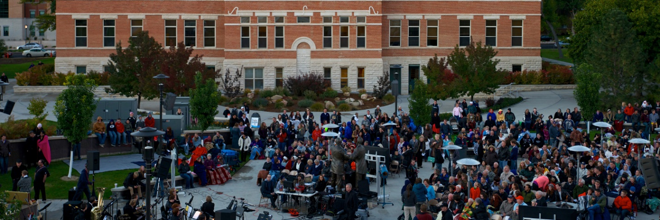

Standard 2B – Human Resources/Personnel

2.B.1The institution employs a sufficient number of qualified personnel to maintain its support and operations functions. Criteria, qualifications, and procedures for selection of personnel are clearly and publicly stated. Job descriptions accurately reflect duties, responsibilities, and authority of the position.
Snow College has added and maintained enough qualified personnel to support the academic and co-curricular needs of students and sustain the operational quality of the institution. Currently the institution has 136.0 full-time and 126 part-time faculty and 181 full-time and 180 part-time staff (includes student hourly workers). The ratio of staff to faculty is 1.35. The following table represents faculty to staff comparisons from Snow College’s peer institutions.
Institution | Faculty | Staff | Staff to Faculty Ratio
Community College of Denver | 206.33 | 217.00 | 1.05
Whatcom Community College | 144.00 | 168.00 | 1.17
Olympic College | 196.33 | 229.67 | 1.17
Georgia Highlands College | 183.00 | 220.33 | 1.20
North Seattle College | 162.33 | 212.00 | 1.31
Columbia Basin College | 180.33 | 237.00 | 1.31
Snow College | 178.00 | 241.00 | 1.35
Colorado Northwestern Community College | 56.33 | 77.00 | 1.37
Clover Park Technical College | 107.00 | 151.67 | 1.42
Carroll College | 107.67 | 157.67 | 1.46
College of Southern Idaho | 260.67 | 432.33 | 1.66
Salt Lake Community College | 723.33 | 1238.00 | 1.71
Midland College | 180.33 | 335.67 | 1.86

Part-time faculty/staff are divided by three and added to full-time faculty/staff to arrive at these numbers. The following policies govern the college’s recruitment, hiring and advancement procedures to ensure a systematic and objective approach for employing qualified personnel.
- Policy 301: Snow College Personnel System
- Policy 302: Statement of Equal Employment Opportunity/Affirmative Action Policy, Application and Purposes
- Policy 315: Hiring, Promotions, and Transfers Policy
- Policy 316: Criminal Background Checks
- Policy 317: Classification Procedure (Staff only)
- Policy 320: Nepotism (All Employees)
- Policy 323: Probationary Period (Staff only)
- Policy 329: Working Hours (Staff only)
- Policy 330: Hourly Payroll Procedures
- Policy 408: Adjunct Hiring Procedure
Each position vacancy announcement contains a job description describing the minimum and desired qualifications, responsibilities, and authority of position. For faculty positions, the duties are determined by the hiring supervisor (faculty dean or department chair) working with the Vice President and Associate Vice President of Academic Affairs. Faculty positions announcements are consistent with academic program needs.
Snow College uses a point-based rating system determined by consensus of each respective hiring committee. Each hiring committee is comprised of relevant faculty and/or staff, related administrators, and human resource personnel.
2.B.2 Administrators and staff are evaluated regularly with regard to performance of work duties and responsibilities.
Snow College faculty and regular staff complete performance evaluations each year. Full-time staff employees are formally evaluated each October by their immediate supervisor using Snow College’s current evaluation forms. Part-time employees have recommended (but optional) annual performance reviews. Probationary employees (including faculty) are evaluated at the end of three months and again prior to the end of six months.
The evaluation of administration occurs annually by the college president with feedback obtained from the administrator’s direct reports. The college president is reviewed by the Snow College Board of Trustees each year. In addition, the Utah State Board of Regents conducts comprehensive evaluations of each president following the first year of his or her tenure and every four years thereafter (Policy R209-4).
2.B.3 The institution provides faculty, staff, administrators, and other employees with appropriate opportunities and support for professional growth and development to enhance their effectiveness in fulfilling their roles, duties, and responsibilities.
All performance reviews are designed to assist faculty and staff in establishing goals and objectives supportive of professional performance and development. The Snow College Faculty Senate sponsors the Faculty Development program that provides a range of opportunities to professional and personal renewal and growth to faculty in all stages of their careers. These activities include but are not limited to
- A Faculty Handbook published annually to help assist faculty fulfill their duties and responsibilities.
- Bi-monthly Lunch Bunch meetings: A soup and salad gathering where faculty can present research, share ideas, and or discuss topics relevant to teaching and best practice.
- An Information Guide for New Faculty that welcomes and orients new faculty to Snow College.
- New Faculty Development Seminar: Weekly meetings for newly hired faculty held throughout fall semester that present topics relative high impact pedagogy and institutional transition/acclimation.
- Campus-wide book reads: An opportunity for faculty to build community and share their experience based on an assigned book. Campus-wide book reads occur for faculty, faculty and staff, and (most recently) female faculty and staff through the Utah Women in Higher Education professional network.
- Undergraduate Quality Initiative (UQI) funds, available (up to $3,000), that provide the means by which faculty and improve themselves. Faculty can apply for UQI funds each year. All faculty UQI applications are approved by the Deans Council.
- Faculty Development Travel Funds: Each academic year, Snow College appropriates money to be used for faculty professional development travel requests. The Deans Council oversees the application and distribution of these funds.
- State Opportunities: Each year, Snow College collaborates with other USHE institutions to provide faculty development by focusing on the best practices at two multi-campus events: The Educated Persons Conference (held each October/November) and The Great Teachers’ Retreat (held each February). In addition, female faculty and staff are encouraged to attend the Utah Women in Higher Education annual conference (held each April).
- General Education Foundations Courses: Beginning fall 2018, faculty from three different disciplines were encouraged to develop inter-disciplinary general education courses. This course would be required of all incoming freshman, providing them with a comprehensive foundation on the purpose of college education and interrelated/growth mindset learning. Faculty developing these courses enjoyed cross discipline pollination of ideas and peer-supported instructional best practices. Each participating faculty member received a stiped for their work.
- Assessment Day provides dedicated, paid time for faculty to convene and assess course and program learning outcomes. Scheduled at the end of each spring semester, this day provides faculty the opportunity to determine previous academic year successes, share ideas within the discipline, and construct coming year improvement plans.
- Sabbatical Leave Program:
Snow College staff and administrators are provided opportunities and support for professional growth through the following:
- Snow College Staff Association includes all full-time and part-time staff at Snow College and serves as a voice for staff in Snow College issues and a provider for staff professional development opportunities. These activities include professional development workshops (held monthly with lunch), staff awards and recognition (held monthly and each semester), recognition opportunities for Snow College staff “unsung heroes”, legislative representation opportunities, and a Fitbit sponsored health and wellness incentive program.
Snow College staff are also provided ample opportunities to attend professional conferences, state-wide meetings, and other trainings.
In addition, all Snow College employees receive regular training on an Alcohol and Drug Free workplace, Americans with Disabilities Act, Sexual Harassment, Corrective Action, and state-mandated Defensive Driving (required to use Snow College vehicles).
2.B.4 Consistent with its mission, core themes, programs, services, and characteristics, the institution employs appropriately qualified faculty sufficient in number to achieve its educational objectives, establish and oversee academic policies, and assure the integrity and continuity of its academic programs, wherever offered and however delivered.
As of all 2019, Snow College employed 136 full-time and 126 part-time instructional faculty. Tenured faculty members numbered 55, another 59 were on-tenure-track, and another 21 were designated as “professional track,” which the institution’s advancement recognition of career and technical education faculty.
Of the 136 full-time faculty, XX hold doctoral or other terminal degrees, XX have non-terminal master’s degrees, and XX possess bachelor’s degrees. In addition, all adjunct teaching faculty hold a bachelor’s degree or higher. The full-time equivalent student to faculty ratio is 20:1.
2.B.5 Faculty responsibilities and workloads are commensurate with the institution’s expectations for teaching, service, scholarship, research, and/or artistic creation.
Snow College faculty are devoted teachers who have very heavy responsibilities. These responsibilities are meant to enrich students’ learning experiences. The Snow College Workload policy (Policy 404) defines basic full-time faculty workload to maintain high standards of excellence in teaching and acknowledge the great things instructors do beyond their professional expectations. With a few exceptions approved by the Dean’s Council, nearly all full-time faculty members have the same workload responsibilities, which are outlined in Policy 404. The baseline instructional workload formula is as follows:
Course Credit Hour + (Course Contact Hour – Course Credit Hour)/2
Nearly all academic labs have twice the contact hours as assigned credit hours and vocational program labs have approximately three times the contact hours as assigned credit hours. In situations where the formula does not adequately represent actual workload, faculty may petition for load adjustment by submitting a Snow College Credit Workload Adjustment Request to the Dean’s Council. The Dean’s Council annually reviews both approved and proposed workload adjustments. All approved adjustments are on file in the Vice President of Academic Affairs office.
2.B.6 All faculty are evaluated in a regular, systematic, substantive, and collegial manner at least once within every five-year period of service. The evaluation process specifies the timeline and criteria by which faculty are evaluated; utilizes multiple indices of effectiveness, each of which is directly related to the faculty member’s roles and responsibilities, including evidence of teaching effectiveness for faculty with teaching responsibilities; contains a provision to address concerns that may emerge between regularly scheduled evaluations; and provides for administrative access to all primary evaluation data. Where areas for improvement are identified, the institution works with the faculty member to develop and implement a plan to address identified areas of concern.
The development of quality full-time faculty is very important to Snow College. All non-tenured full-time faculty members participate in annual performance reviews conducted by their respective department chair. Tenured faculty members complete three-year performance evaluations by their respective academic dean. Beginning spring 2019, the faculty review process for advancement and tenure implemented review by a Faculty Evaluation Team (FET) comprised of discipline-related faculty peers. These reviews are summative in nature and used to make recommendations to Snow College’s Advancement and Tenure committee by a faculty member’s standing. All reviews focus on teaching, professional development, and service and are submitted to the Office of Academic Affairs upon completion.
Snow College policy 402: Academic Due Process: Sanctions and Hearing Procedures and Policy 403: Academic Due Process: Grievances outline the measures that address faculty performance areas of concern. Snow College is dedicated to the improvement of all faculty members. For example, Policy 402 describes non-punitive measures such as guidance, counseling, therapy, leave of absence, voluntary resignation, or early retirement that are considered in lieu of sanctions. The imposition of sanctions (at various levels) are designed to induce self-improvement and reform by a faculty member, indicate the seriousness of the professional misconduct, and reassure the institutional community that violations of standards of conduct are not tolerated.

The Snow College website is in the process of transitioning policies approved under the old format to the new format for improved consistency and greater transparency.

