# **Richfield Campus Enrollment History and 6-County Economic Outlook *Prepared by the Office of Institutional Research & Effectiveness (Dr. Beckie Hermansen) (January 2020).***

Since 1920, Sevier County desired to secure a junior college in Richfield, Utah. It was not until 1970 that construction began on the Sevier Valley Technology Center, and by 1977 the first cohort of an estimated 200 students enrolled in classes on auto mechanics, auto body work, building trades, business, business machine repair, commercial art and graphics, cosmetology, diesel mechanics, drafting, electronics, nurse’s aid training, and welding.

Enrollment at the Sevier Valley Technology Center grew until the facility was merged with Snow College in 1999. Approximately 60% of this enrollment were high school students seeking skills to get a job, not a degree. From 1987 to 1996, headcount enrollment averaged 1,318 students (FTE average = 435.0) with the highest enrollment of 1,617 students (511.2 FTE) in 1996.

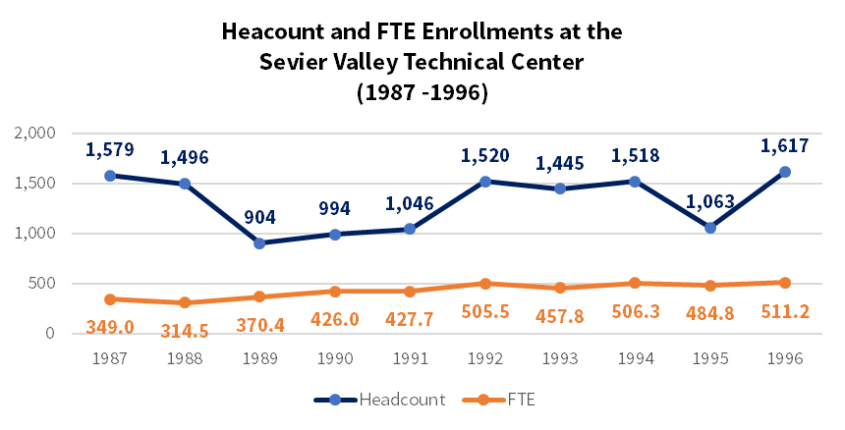

Click on image for larger view

Programs offered during this time were accounting, autobody, auto mechanics, building trades, business, commercial art, computer systems, cosmetology, data processing, diesel mechanics, drafting, electronics, farm/ranch management, food service, licensed nursing, welding, multimedia, applied math, related education, machine tool, and plumbing.

In 1998, the Utah State Legislature merged the former Sevier Valley Applied Technology Center with Snow College (HB114). The aim of the merger was to simplify the process for students seeking college credit for technology center coursework. There was strong concern over the merger particular to increased program costs (estimated to be 70% higher at colleges than technical schools) and higher tuition expenses. Students at Sevier Valley Technology Center paid $.85/hour for instruction (1998) compared to college tuition, which was significantly higher.

Since the merger, the Snow College Richfield campus has maintained its strong applied technology education programs and provided a growing number of academic courses to compliment the academic offerings of the main, Ephraim campus. However, headcount and FTE enrollments have significantly declined.

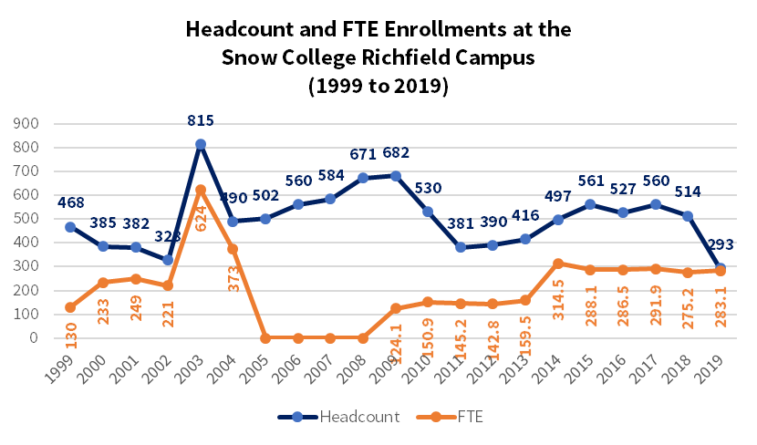

Click on image for larger view

The highest headcount and FTE for the Richfield campus was in 2003 with 815 students (mixed high school and post-secondary). At that time, high school students received dual college and high school credit for their technical skills training. This was tracked through seat time and calculated as membership hours, which were reported to the Utah System of Higher Education (USHE) as membership FTE—a compliment to the traditional FTE produced by Snow College’s main (Ephraim) campus. Until 2010, many local high schools provided release time and bus service for students to take their skills classes on the Richfield campus.

The drop in enrollment around 2010 was due to public education’s change to the common core curriculum and high school graduation requirements. This limited the time (and subsequent opportunity) local high school students had to take the technical training coursework provided by the Richfield campus. In 2012, the high school concurrent enrollment program expanded to offer general education college instruction state-wide using distance education technology and approved face-to-face instruction at participating high schools. Collectively, these changes have negatively impacted Richfield campus enrollments, which have averaged only 467 students and 233.7 FTE over the past ten years (2010 – 2019).

**Programs at Sevier Valley Technology Center**  
*offering certificates of achievement*

**Accounting**Autobody  
**Auto Mechanics**Building Trades  
Commercial Art  
**Computer Systems  
Cosmetology  
Data Processing  
Diesel Mechanics**Drafting  
Electricity  
Electronics  
**Farm/Ranch Management**Food Service  
**Licensed Nursing  
Welding**Multimedia  
Applied Math  
Related Education  
**Machine Tool**Plumbing

The **orange highlighted** programs continue to be offered on the Richfield campus.

**Programs and Snow College, Richfield Campus**  
*offering Associate of Science, Associate of Arts, Associate of Science-Business, Associate of Science-Nursing, Associate of Applied Science, Certificates of Proficiency, Certificates of Completion and Awards.*

Agribusiness  
Agricultural Technology  
Automotive Technology  
Business  
Computer Information Systems  
Diesel Mechanics Technology  
Industrial Manufacturing  
Industrial Mechanics  
Machine Tool Technology  
Natural Resources  
Nursing  
Outdoor Leadership  
Salon Business Technology  
Welding Technology

# Sevier County Information:

|  |  |  |
| --- | --- | --- |
| **Population 2010** | **Population 2018** | **Percent Change** |
| **20,822** | **21,539** | **+3.5%** |

|  |  |  |
| --- | --- | --- |
| **Median Household Income** | **Percent of Persons Living in Poverty** | **Poverty by Age and Gender** |
| $53,020 | 12% | Females, 18-24 |

|  |  |
| --- | --- |
| **Percent of Persons 25+ with HS Diploma** | **Percent of Persons 25+ with bachelor’s degree** |
| **90%** | **17%** |

|  |  |  |
| --- | --- | --- |
| **Unemployment Rate** | **Percent of Minority Population** | **Largest Minority Population** |
| 3.6% | 9% | Hispanic at 5.4% |

As of 2017, the economy of Sevier County employed 8.63k people in the following industries: Retail Trade, Health Care & Social Assistance, and Educational Services. Employment by specific occupations

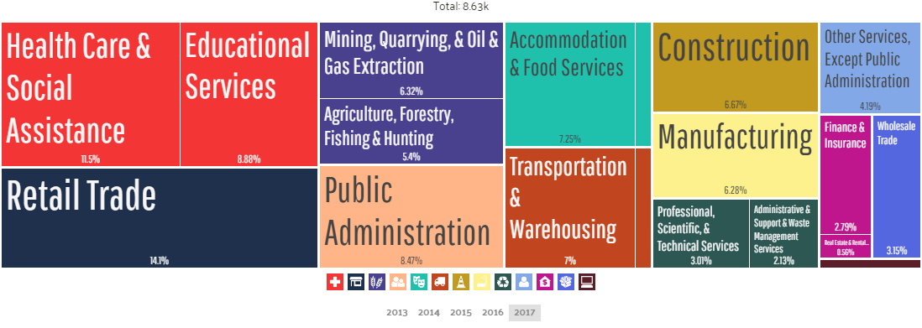

The highest paid occupations are (in order): legal, architecture/engineering, health diagnosing/treating practitioners, computer engineering and science, and management.

The highest paying industries by median earnings: Utilities ($93,750), Finance & Insurance ($71,250), and Mining, Quarrying, & Oil & Gas Extraction ($66,959).

|  |  |  |
| --- | --- | --- |
| **Percent of Population with Health Coverage** | **Average patients seen per year by Primary Care Physicians** | **Average patients seen per year by Mental Health Providers** |
| 87.4% | 1,908 | 495 |

# Sevier County Educational Attainment by Age and Gender

Highlighted in each chart is the percentage of popoulation with Some College, No Degree

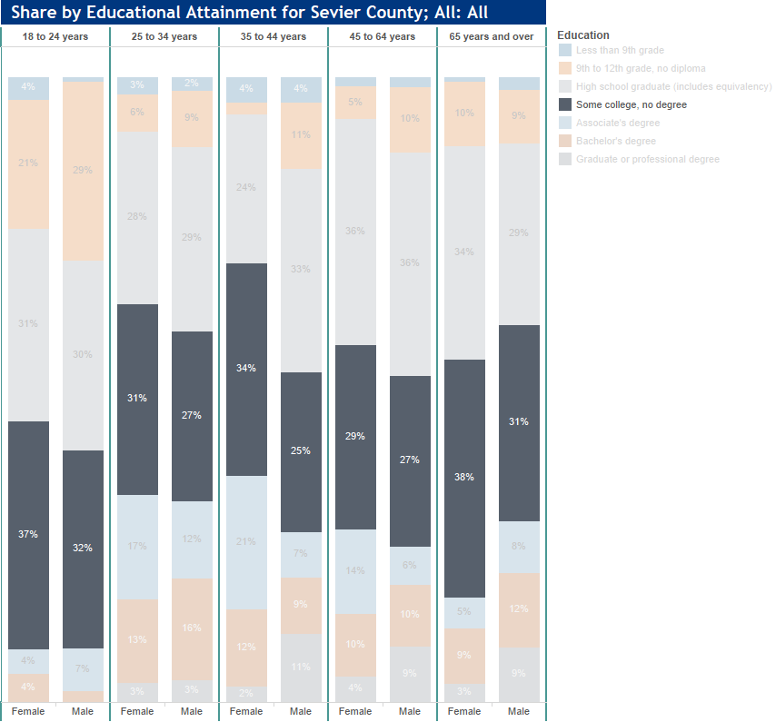

Sevier County Education Attainment by Labor Force Status 2013 – 2017 for Population 25-64 years

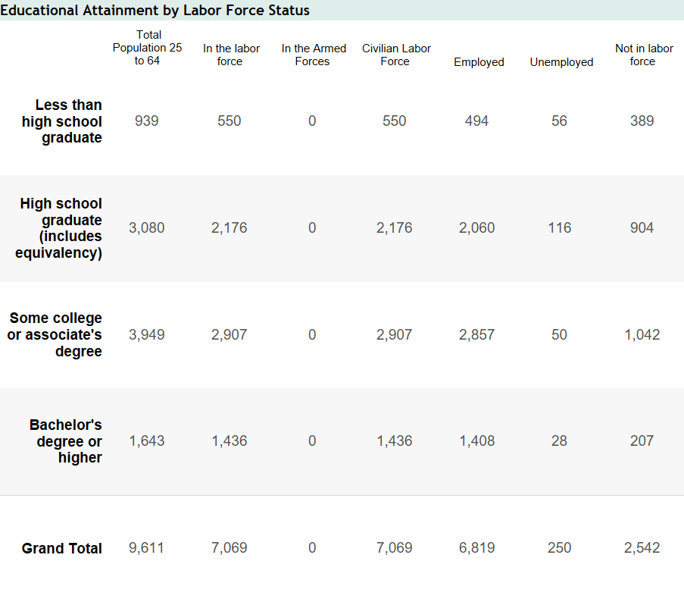

# Juab County Information:

|  |  |  |
| --- | --- | --- |
| **Population 2010** | **Population 2018** | **Percent Change** |
| **10,246** | **11,555** | **+12.8** |

|  |  |  |
| --- | --- | --- |
| **Median Household Income** | **Percent of Persons Living in Poverty** | **Poverty by Age and Gender** |
| $62,237 | 9% | Females, 6-11 |

|  |  |
| --- | --- |
| **Percent of Persons 25+ with HS Diploma** | **Percent of Persons 25+ with bachelor’s degree** |
| **92%** | **17%** |

|  |  |  |
| --- | --- | --- |
| **Unemployment Rate** | **Percent of Minority Population** | **Largest Minority Population** |
| 3.0% | 8% | Hispanic at 5.1% |

As of 2017, the economy of Sevier County employed 4.6k people in the following industries: Retail Trade, Health Care & Social Assistance, and Educational Services. Employment by specific occupations

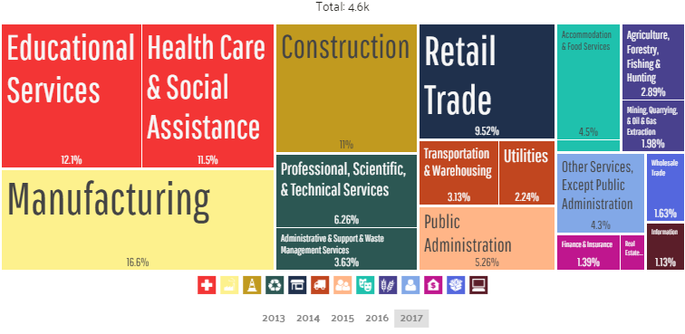

The highest paid occupations are (in order): Fire Fighting & Prevention & Other Protective Services Including Supervisors, Architecture & Engineering Occupations, and Health Diagnosing & Treating practitioners and Other Technical Occupations.

The highest paying industries by median earnings: Real Estate & Rental & Leasing ($98,125), Utilities ($86,058), and Mining, Quarrying & Oil & Gas Extraction ($57,031).

|  |  |  |
| --- | --- | --- |
| **Percent of Population with Health Coverage** | **Average patients seen per year by Primary Care Physicians** | **Average patients seen per year by Mental Health Providers** |
| 92.1% | 1,742 | 352 |

# Juab County Educational Attainment by Age and Gender

Highlighted in each chart is the percentage of popoulation with Some College, No Degree

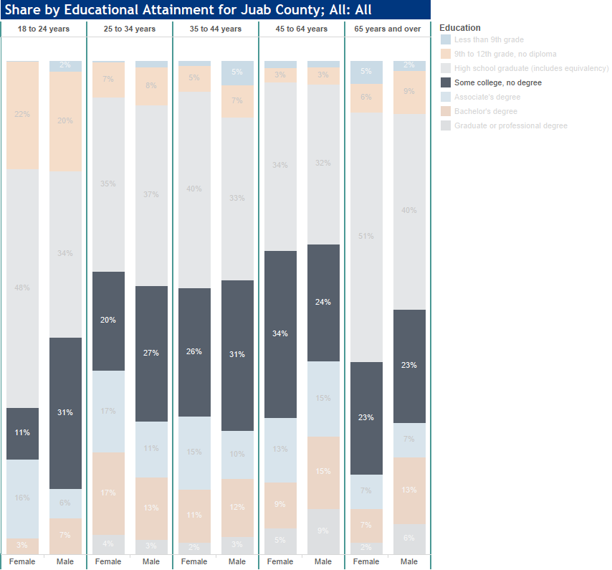

Juab County Education Attainment by Labor Force Status 2013 – 2017 for Population 25-64 years

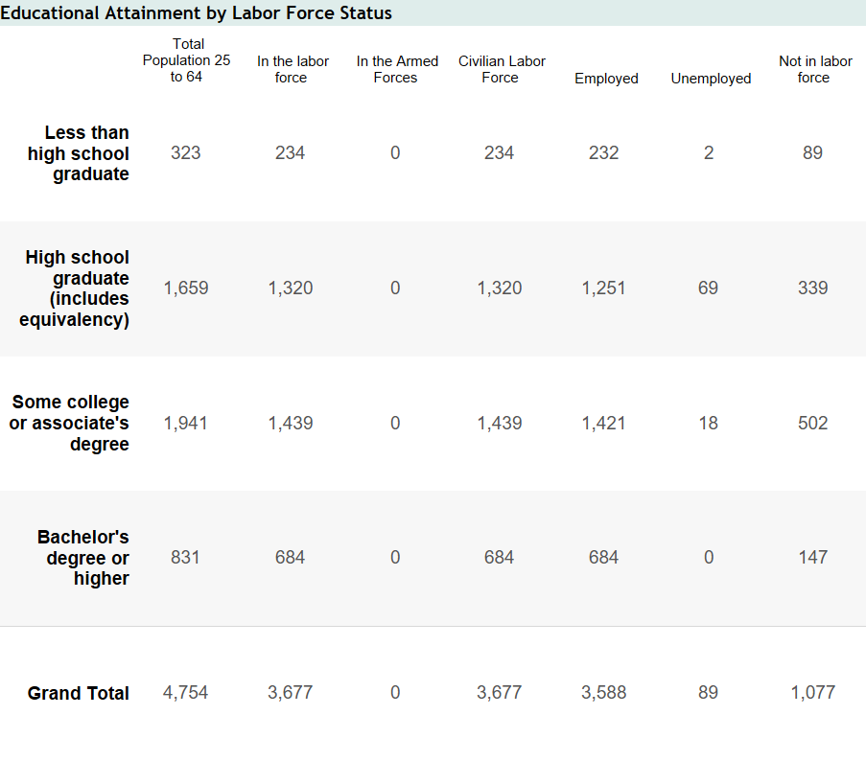

# Millard County Information:

|  |  |  |
| --- | --- | --- |
| **Population 2010** | **Population 2018** | **Percent Change** |
| **12,503** | **13,006** | **+4.0** |

|  |  |  |
| --- | --- | --- |
| **Median Household Income** | **Percent of Persons Living in Poverty** | **Poverty by Age and Gender** |
| $60,445 | 11% | Females, 25-34 |

|  |  |
| --- | --- |
| **Percent of Persons 25+ with HS Diploma** | **Percent of Persons 25+ with bachelor’s degree** |
| **89%** | **22%** |

|  |  |  |
| --- | --- | --- |
| **Unemployment Rate** | **Percent of Minority Population** | **Largest Minority Population** |
| 3.0% | 17% | Hispanic at 13.2% |

As of 2017, the economy of Sevier County employed 5.55k people in the following industries: Agriculture, Forestry, Fishing & Hunting, Utilities, and Retail Trade

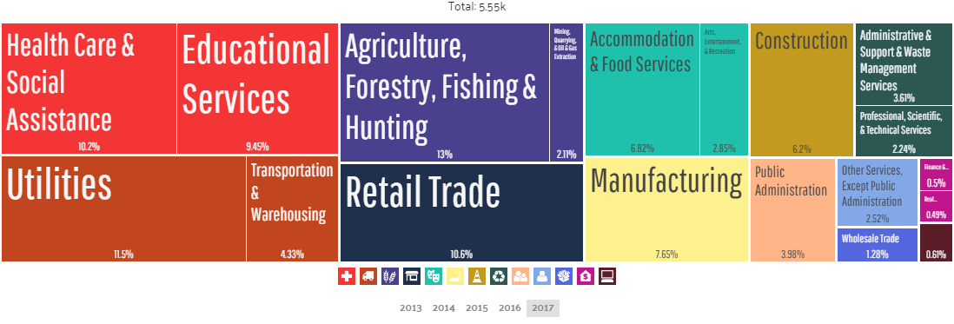

The highest paid occupations are (in order): Computer & Mathematical, Architecture & Engineering, Computer Engineering & Science, Life/Physical and Social Science, and Health Diagnosing Treating Practitioners & Other Technical Service occupations.

The highest paying industries by median earnings: Utilities ($77,500), Transportation & Warehousing & Utilities ($74,185), and Information ($67,750).

|  |  |  |
| --- | --- | --- |
| **Percent of Population with Health Coverage** | **Average patients seen per year by Primary Care Physicians** | **Average patients seen per year by Mental Health Providers** |
| 86.3% | 2,108 | 1,058 |

# Millard County Educational Attainment by Age and Gender

Highlighted in each chart is the percentage of popoulation with Some College, No Degree

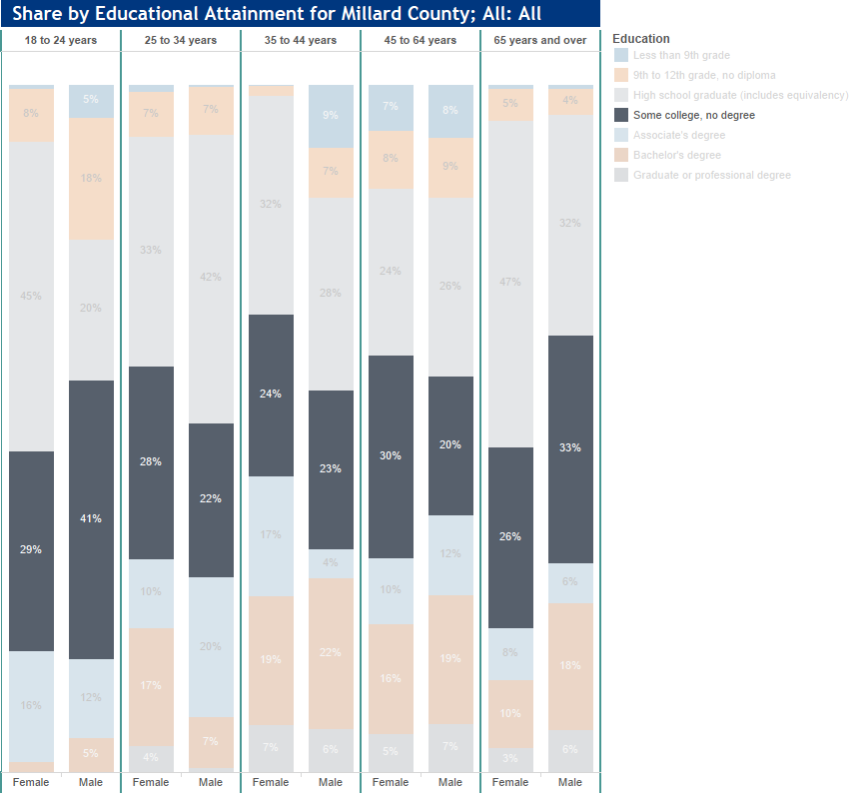

Millard County Education Attainment by Labor Force Status 2013 – 2017 for Population 25-64 years

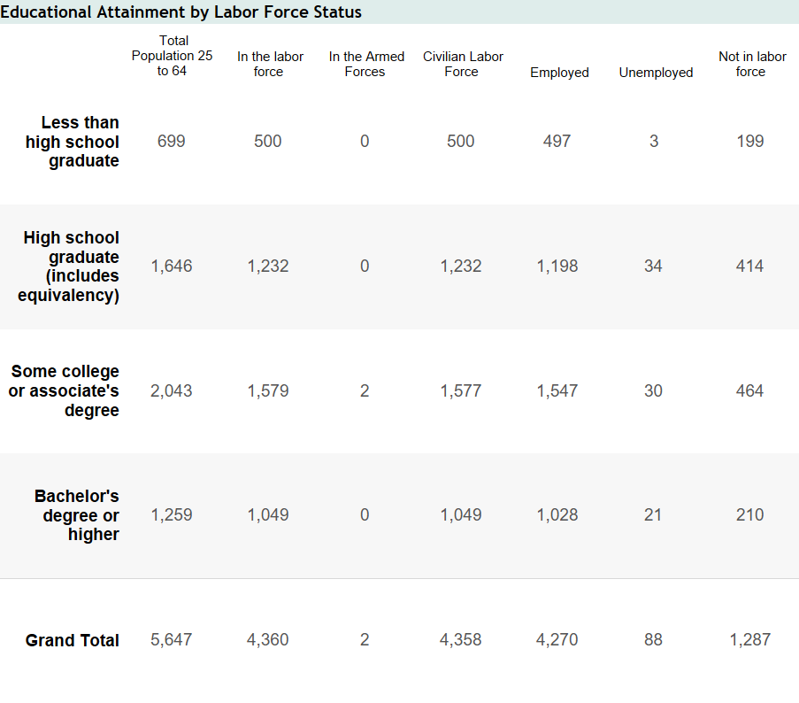

# Piute County Information:

|  |  |  |
| --- | --- | --- |
| **Population 2010** | **Population 2018** | **Percent Change** |
| **1,556** | **1,445** | **-7.1** |

|  |  |  |
| --- | --- | --- |
| **Median Household Income** | **Percent of Persons Living in Poverty** | **Poverty by Age and Gender** |
| $39,440 | 19% | Females, 25-34 |

|  |  |
| --- | --- |
| **Percent of Persons 25+ with HS Diploma** | **Percent of Persons 25+ with bachelor’s degree** |
| **87%** | **19%** |

|  |  |  |
| --- | --- | --- |
| **Unemployment Rate** | **Percent of Minority Population** | **Largest Minority Population** |
| 5.3% | 10% | Hispanic at 7.5% |

As of 2017, the economy of Sevier County employed 636 people in the following industries: Accommodation & Food Services, Retail Trade, and Manufacturing.

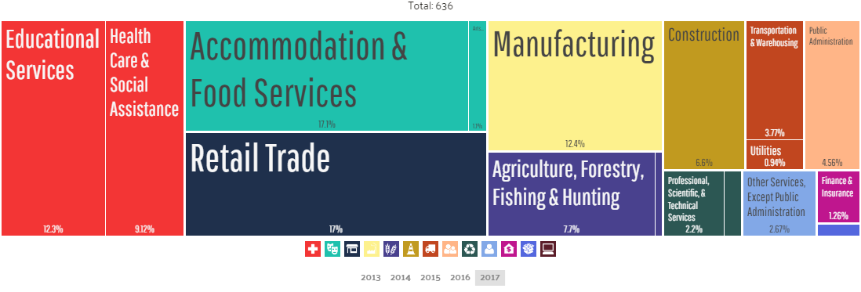

The highest paid occupations are (in order): Management, Health Diagnosing & Treating Practitioners and Other Technical occupations.

The highest paying industries by median earnings: Public Administration ($50,652), Other Services Except Public Administration ($44,374), and Manufacturing ($43,609).

|  |  |  |
| --- | --- | --- |
| **Percent of Population with Health Coverage** | **Average patients seen per year by Primary Care Physicians** | **Average patients seen per year by Mental Health Providers** |
| 80.1% | 0 | 244 |

# Piute County Educational Attainment by Age and Gender

Highlighted in each chart is the percentage of popoulation with Some College, No Degree

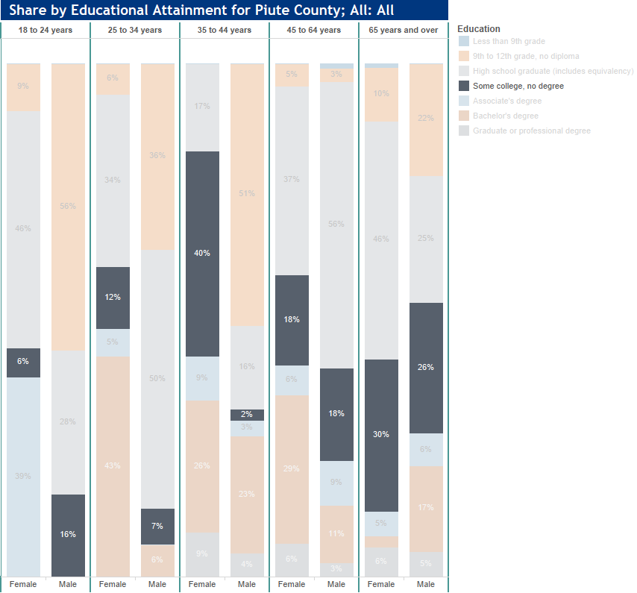

Piute County Education Attainment by Labor Force Status 2013 – 2017 for Population 25-64 years

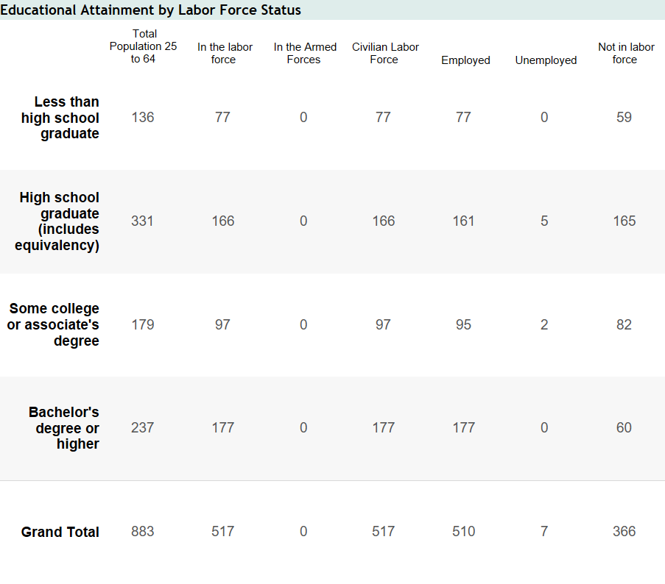

# Wayne County Information:

|  |  |  |
| --- | --- | --- |
| **Population 2010** | **Population 2018** | **Percent Change** |
| **2,778** | **2,690** | **-3.2** |

|  |  |  |
| --- | --- | --- |
| **Median Household Income** | **Percent of Persons Living in Poverty** | **Poverty by Age and Gender** |
| $44,694 | 13% | Females, 55-64 |

|  |  |
| --- | --- |
| **Percent of Persons 25+ with HS Diploma** | **Percent of Persons 25+ with bachelor’s degree** |
| **89%** | **25%** |

|  |  |  |
| --- | --- | --- |
| **Unemployment Rate** | **Percent of Minority Population** | **Largest Minority Population** |
| 6.1% | 10% | Hispanic at 6.9% |

As of 2017, the economy of Sevier County employed 122k people in the following industries: Accommodation & Food Services, Construction, and Educational Services.

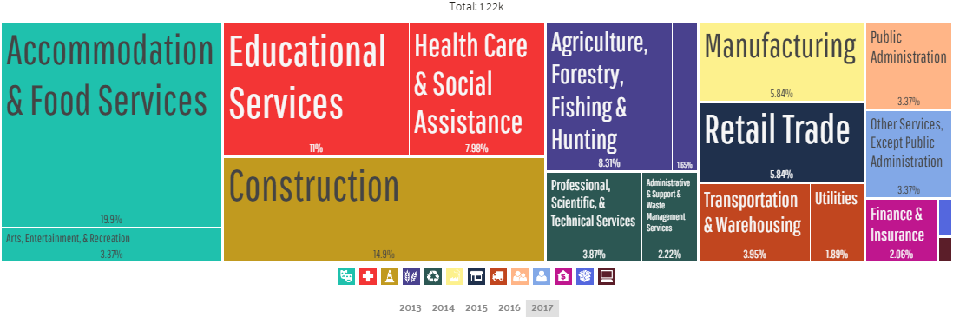

The highest paid occupations are (in order): Health Diagnosing & Treating Practitioners and Other Technical Persons, Computer Engineering and Science, Management, and Business & Financial occupations.

The highest paying industries by median earnings: Finance & Insurance & Real Estate & Leasing ($80,096) and Utilities ($73,542).

|  |  |  |
| --- | --- | --- |
| **Percent of Population with Health Coverage** | **Average patients seen per year by Primary Care Physicians** | **Average patients seen per year by Mental Health Providers** |
| 79.2% | 0 | 225 |

# Wayne County Educational Attainment by Age and Gender

Highlighted in each chart is the percentage of popoulation with Some College, No Degree

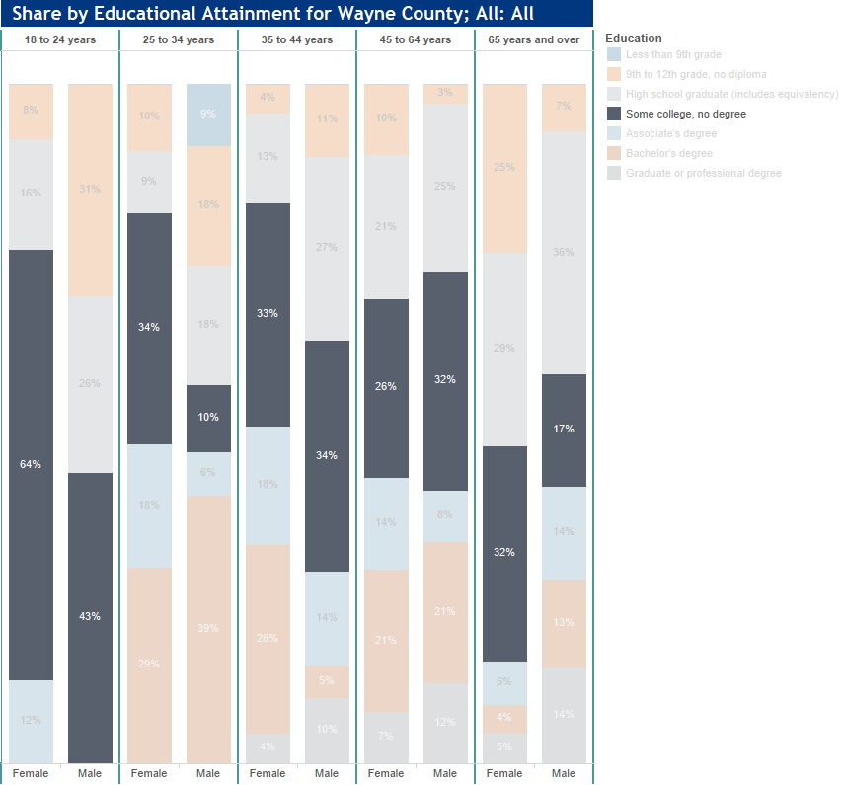

Wayne County Education Attainment by Labor Force Status 2013 – 2017 for Population 25-64 years

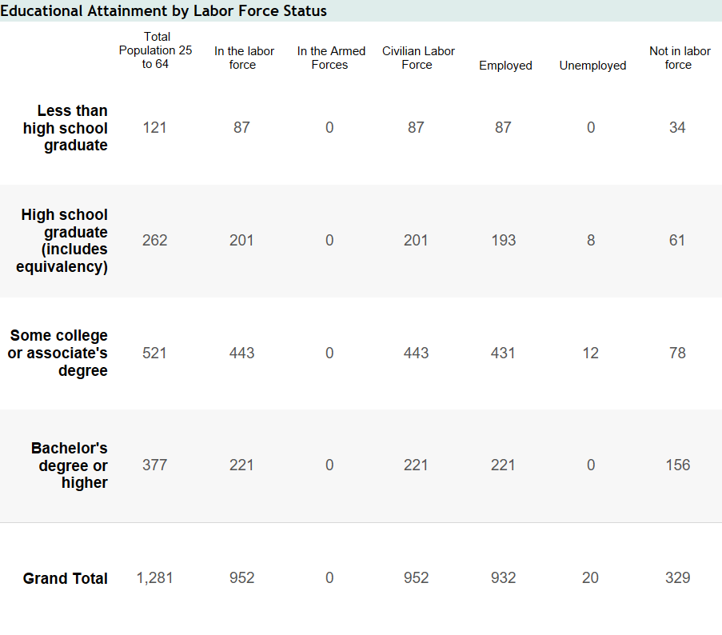

# Sanpete County Information:

|  |  |  |
| --- | --- | --- |
| **Population 2010** | **Population 2018** | **Percent Change** |
| **27,822** | **30,623** | **+10.1** |

|  |  |  |
| --- | --- | --- |
| **Median Household Income** | **Percent of Persons Living in Poverty** | **Poverty by Age and Gender** |
| $51,720 | 15% | Females, 18-24 |

|  |  |
| --- | --- |
| **Percent of Persons 25+ with HS Diploma** | **Percent of Persons 25+ with bachelor’s degree** |
| **90%** | **19%** |

|  |  |  |
| --- | --- | --- |
| **Unemployment Rate** | **Percent of Minority Population** | **Largest Minority Population** |
| 3.8% | 13% | Hispanic at 9.7% |

As of 2017, the economy of Sevier County employed 10.8k people in the following industries: Educational Services, Retail Trade, Health Care & Social Assistance.

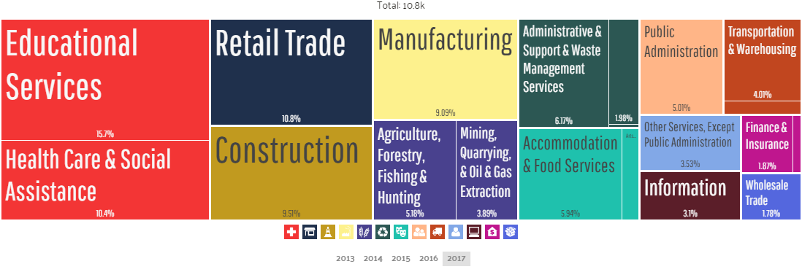

The highest paid occupations are (in order): Architecture & Engineering, Business & Financial, Computer Engineering and Science, Computer & Mathematical, Health Diagnosing & Treating Practitioners and Other Technical persons occupations.

The highest paying industries by median earnings Mining, Quarrying & Oil & Gas Extraction ($65,799), Transportation & Warehousing ($40,455), and Professional Scientific & Technical Services ($40,227).

|  |  |  |
| --- | --- | --- |
| **Percent of Population with Health Coverage** | **Average patients seen per year by Primary Care Physicians** | **Average patients seen per year by Mental Health Providers** |
| 86.9% | 1,693 | 125 |

# Sanpete County Educational Attainment by Age and Gender

Highlighted in each chart is the percentage of popoulation with Some College, No Degree

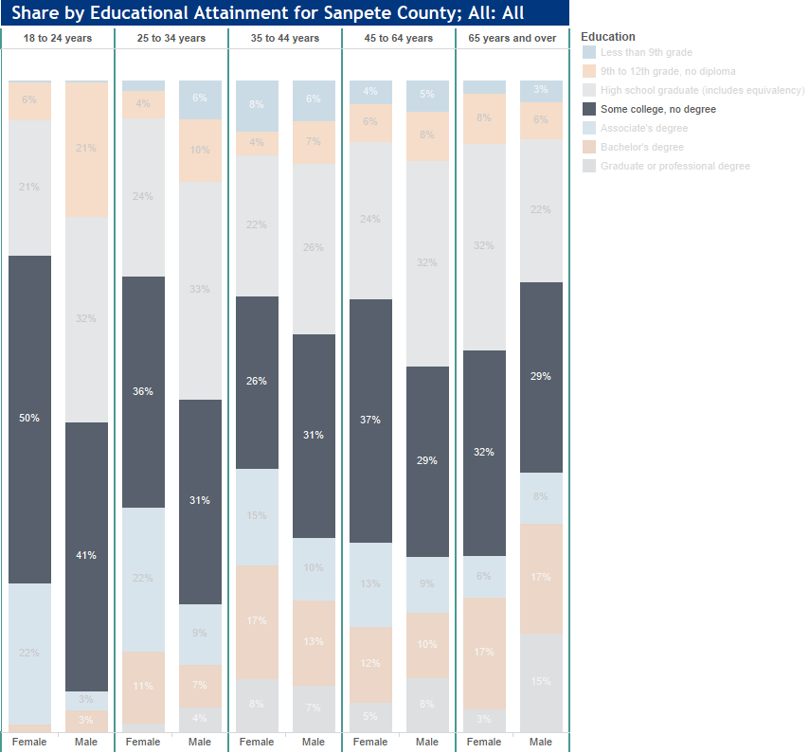

Sanpete County Education Attainment by Labor Force Status 2013 – 2017 for Population 25-64 years

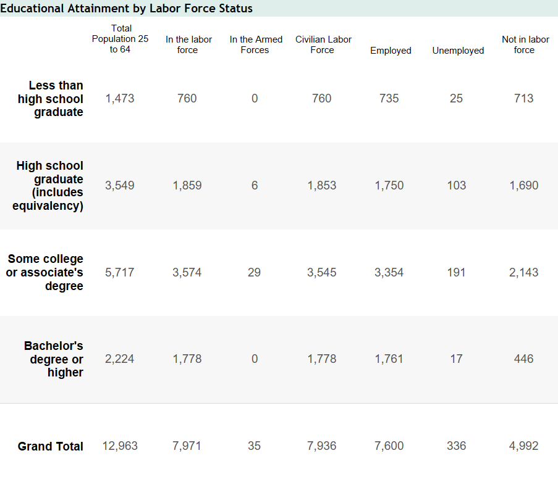

# 

# Data and Information Sources:

* Lisa Jones, Snow College Richfield Financial Services Office.
* DataUSA: <https://datausa.io/> (for each respective county). Data current to 2017.
* Best Places: <https://www.bestplaces.net/> (for each respective county). Used for the most current unemployment data.
* U.S. Census Bureau QuickFacts: <https://www.census.gov/quickfacts> (for each respective county).
* Educational Attainment Dashboard images provided by Utah Department of Workforce Services <https://jobs.utah.gov/wi/data/library/other/eduattainment.html>

