Badger Web Finance is a web based interface that accesses account information from Banner. Badger Web Finance is updated in real time with Banner and reflects the current information as posted in Banner. Badger Web Finance can answer the following questions:
*Find your Budget amounts in the Budget Booklets for the new fiscal year.
www.snow.edu – Offices – Budget Office (Currently under Controller’s Office) Rt Side
- What’s my budget balance?
- What expenses have hit my account so far this year?
- Did my budget transfer go through yet?
- Have I been paid for this yet?
- Etc.
Below are instructions on how to use Badger Web Finance.
- Log In to the Badger Web system. Here is a link to the log in page.
  - https://badgerweb.snow.edu

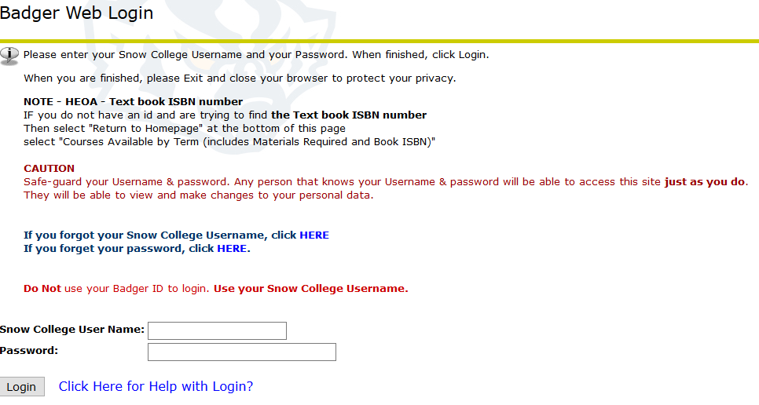

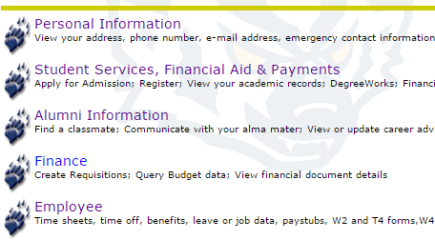
- After you've logged in, click on the "Finance" button.

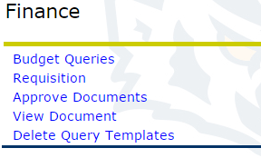
- Next Click “Budget Queries."

- Make sure the “Create a New Query” drop down menu says "Budget Status by Account" then click "Create Query."
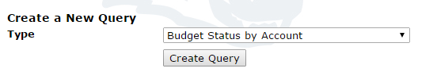
- Check the desired options and then click “Continue.” If you would like to save the Query, enter the name before clicking “Continue”. DO NOT select shared.
  - The recommended options are the ones checked in the below picture.
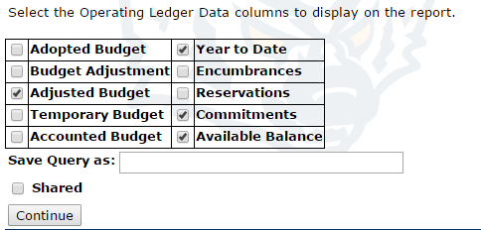

- Make sure the “Fiscal year” box says the current fiscal year (e.g. 2017 for the fiscal year ending June 30, 2018). The “Fiscal period” allows you to view all activity from the beginning of the fiscal year through the end of the designated month (e.g. putting 3 would allow you to see July through September). If you want to see the whole year, put 12 in the “Fiscal period” box. The “Comparison Fiscal Year” box and the “Comparison Fiscal Period” boxes should say "None" if you only want to see the current year activity or you can compare last year or last month. The “Chart of Accounts” option should be "S". Put the account you wish to view in the “Index” box. Make sure all other fields are empty. "Include Revenue Accounts" should be checked. Then click “Submit Query” (Do not hit “Enter” or this will take you to an unintended screen).
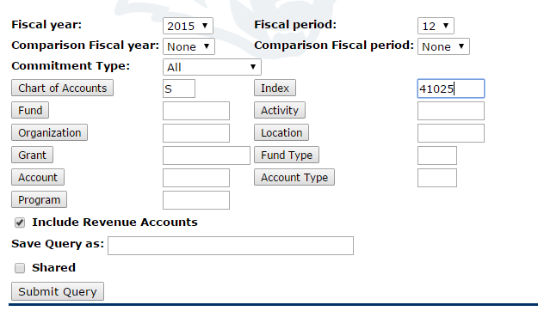
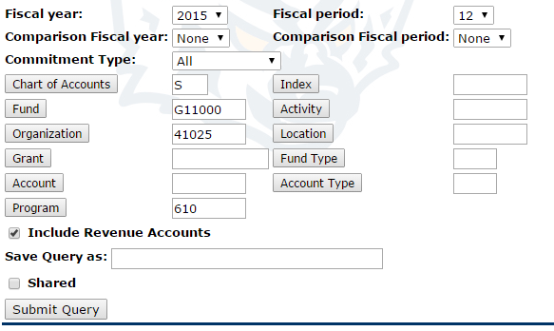
- That will auto populate all fields. Then click “Submit Query” again.

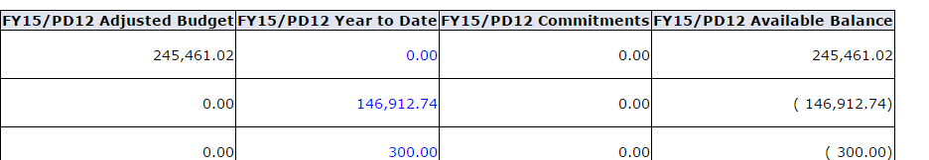
- Now you should be at a screen that shows all account activity.

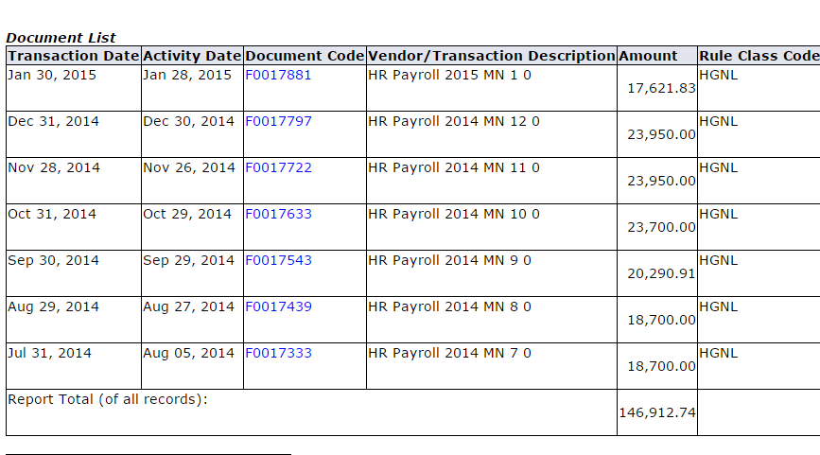
- You can click on the blue hyperlinks to see the detail for each account.

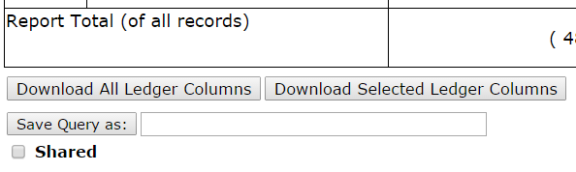
- Export to Excel by clicking on “Download Selected Ledger Columns”.
Highlight A1:C9 – Copy (Control C)
Hide Columns A-I / L-Q
Paste (Control V) on R1
Insert Column after Fiscal Year
Highlight Adjusted Budget – next 3 columns - add comma

ORGS (5 numbers)
In new column, at bottom of YTD activity of each section: add Adjusted budget then subtract sum of YTD activity. = T18-SUM(U18:U20)

*Main focus is for the Hourly Wages & Current Expense Budget*

FUNDS (Lettered & 5 numbers)
Insert Row after 5xxx accounts
Sum YTD & Commitments in new column at end of 5xxx’s & end of 7xxx’s
Add “Total” in Column R
Subtract Expenses from Revenue

FAQs (Frequently Asked Questions)
- I entered my account into the query, but no activity shows up in the query results?
This usually means that you have not been given access to view that account. You will need to have the account holder responsible for that account, contact the Controller’s Office (x7263 or co@snow.edu) requesting access for you to that account.
- What if my account has a letter followed by five digits (e.g. R20000)?
Your spendable cash balance may not be able to be calculated based on just the information in Badger Web Finance. You may need to contact the Controller’s Office (x7263 or co@snow.edu) to find out your spendable cash balance. You can still see all of the year-to-date activity that has hit your account.
- How do I know what my account balance is?
If you want to know the entire balance of your account including salaries, wages, and expenses, then you would take the total from the “Adjusted Budget” column and then add the total from the “Year to Date” column. Note that the “Adjusted Budget” column will appear as negative amounts. You should consider these as positive instead of negative. The “Year to Date” column will reflect the correct positive or negative amount. This will give you your remaining balance. In the example below, you would take $481,916.60 minus $265,262.61 which would give you a balance of $216,653.99.

If you only want to find out your balance for wages, expenses, etc., then you would find the “Adjusted Budget” amount for that type of expense (Salary – 6100, Wages – 6200, Benefits – 6300, Current Expenses – 7001, etc.). Then you would need to add together all of the expenses listed under that type of expense (e.g. all expenses listed as 61xx would be matched against the “Adjusted Budget” 6100 amount).
In the example below you would take the “Adjusted Budget” 6100 amount of $245,461.02 and subtract the “Year to Date” 61xx accounts to arrive at your remaining salary amount of $98,248.28.
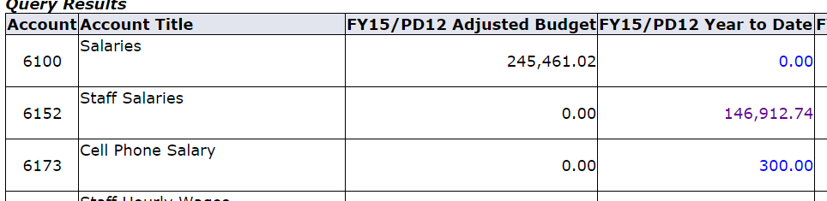
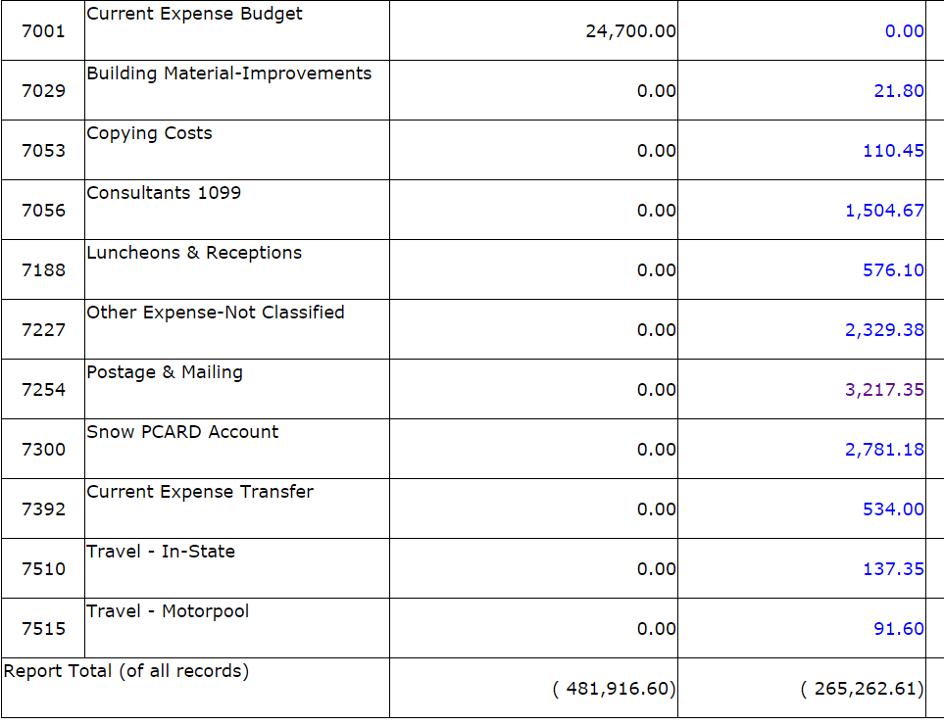
If you wanted to find out the remaining current expense balance in the example below, you would take the “Adjusted Budget” 7001 amount of $24,700 and subtract out all of the “Year to Date” 7xxx amounts to arrive at a remaining balance of $13,396.12.
You can easily export this information into Excel so that you don’t have to manually calculate the balances. See Step 10 above.
- I don’t think my account balance is correct, is something missing?
Check your query and make sure you followed step 6 correctly. If any information was left in there from a prior query, it will try and query on what is in those fields which will alter your results. If that doesn’t resolve your question go to the next two questions.
- I don’t see some income that I am expecting?
This means that the income has not yet been recorded or that it was recorded elsewhere. If you are expecting money from an outside source, check with that source to make sure they have sent the money. If they have already sent the money, and we should have received it by now, check with the Controller’s Office (x7263 or co@snow.edu) to see if it got recorded in another account.
- I don’t see an expense that I am expecting?
Pcard expenses only hit your account once a month at the end of the month after the monthly Pcard statements are finalized. If it is a Pcard expense, it will only hit your account once a month at the end of the month. Check requests are usually processed twice a week. If it is a check request, it won’t hit your account until the next check run is processed. Budget transfers are usually processed once a week by the Controller’s Office. If it is a budget transfer, it likely won’t hit your account until the following week.
- Why can’t I see my individual Pcard transactions?
Only the total Pcard monthly statement amount is uploaded into your account. If you want to see individual Pcard transactions, you will need to keep a copy of your receipts or log into your US Bank account to view those.
- Can I see how much person A was paid out of my account?
No. Only the total monthly payroll amount hits your account. You will have to contact HR/Payroll to see who got paid and how much.
- Why do I have a negative expense (normally in Current Expense Transfer)?
Only Funds (lettered accounts) can receive revenue. Orgs (numbered accounts) can receive funds but they will come in the form of a negative expense or transfer. This will offset your other expenses allowing you to spend more.
For Example: Current expense Budget = 5,000. You have spent 4,500. So now you only have 500 left to spend. You received funds of 3,000 in the form of a negative current expense transfer. So now you still have 3,500 left to spend.
- Can I save the query so I don’t have to enter the information every time?
Yes. At any stage in the query entering process, you can save the query by putting a name in the “Save Query as:” box.
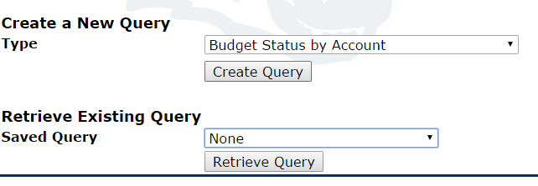
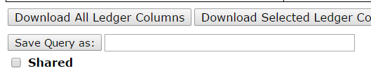
Then at step 4 above, you can retrieve it by selecting it from the “Saved Query” dropdown box.
- What if I don’t have a “Finance” tab in Badger Web?
This means you have not been given access to it yet. You will need to have your account holder contact the Controller’s Office (x7263 or co@snow.edu) and request access for you.

